|  |
| --- |
|  |
| COMPUTER SECURITY ASSIGNMENT |
| Module - LD-7089 |
|  |
| **Student Name – Shabina**  **Student ID - w21060994**  **MSc. Cyber Security Technology with Advance Practice**  **Northumbria University – London Campus**  **Faculty -**  **Dr. Khaled El-Hussein** |
|  |

|  |
| --- |
|  |

Table of Contents

Introduction: 7

Task 1: – Security Elements 7

Confidentiality 8

Integrity 9

Availability 9

Authenticity 9

Utility 9

Countermeasures 9

Conclusion 10

Task 2: Computer Security Issues: 11

Threat Intelligence 11

Prevent data loss 11

Provide direction on safety measures 11

Inform others 11

Compliance 11

Who benefits from threat intelligence? 11

Threat intelligence life cycle 11

Threat Modelling Methods 12

Stride Threat Model 13

DREAD Threat model 14

Damage Potential 14

Reproducibility 14

Exploitability 14

Affected Users 14

Discoverability 14

Task 3: - Security Frameworks: 16

NIST CSF framework and ISO27001 recommendation for Need4help: 18

How does the NIST affect Need4help Charity? 18

What happens if a charity is not NIST compliant? 19

TASK 4: ACL – Access Control List 20

1. User objects 20

2. Group objects 20

3. Default groups 20

4. Securing administrative accounts 20

5. Group Policy 20

6. Configuring users and groups 20

Demonstration: 21

New Dept creation: 38

Create Security Group 40

Policy Management: 43

Adding Group users and Domain users: 45

Linking the group policy created to Organization unit 55

Validation of Group Policy Object Implementation: 57

Task 5: Social, Ethical and Legal Considerations 59

Responsibility 59

Confidentiality 59

Integrity 59

Fairness 59

Respect 59

1.Professionalism: 59

2.Ethical behavior 59

3.Social responsibility 60

4.Legal compliance 60

Conclusion 60

References 61

Table of Figures

Fig 1: Elements In Computer Security: Confidentiality |Integrity | Availability (Developed by author) 7

Fig 2: NIST Cybersecurity Framework, DFARS, 800-171(Gaithersburg,MD, 2013) 8

Fig 3: Six Stages of Threat Intelligence of life cycle (chowdhury, 2019) 12

Fig 4: A Threat model Venn diagram Source.( Schaumann, 2022) 13

Fig 5: DREAD Methodology. (EC-Council, 2022) 15

Fig 6: Choose custom option to select virtual hard define earlier 21

Fig 7: Select the virtual drive defined earlier 22

Fig 8:Installation in progress 22

Fig 9: Select Password 23

Fig 10: Main page after installation 23

Fig 11: To use Ctrl+Alt+Delete in Virtual box machine either use Menu >Input >Insert Ctrl+Alt+Del as shown above or use Shift+Ctrl+Alt+Del in keyboard either will work 24

Fig 12:Enter password as setup earlier 24

Fig 13: Search for server manager and open – Server dashboard is visible as we open server manager 25

Fig 14:Click on Manage > add Roles and features 25

Fig 15: This page tells us what the wizard does and also reminds us of important tasks to carry out >Read the details and click next 26

Fig 16: Select Role based or feature based installation 26

Fig 17:Server manager allows us to manage multiple servers, in this case there is only one server configured hence select and click next 27

Fig 18: The installation prompts to select the role or roles > in this case we select Active Directory Domain Services 27

Fig 19: System prompts to add features required by Active Directory Domain Services > Click on add features 28

Fig 20: Notice on top right corner it shows the server we are installing the features on > click next 28

Fig 21: On this screen Group Policy Management has been selected automatically, click next 29

Fig 22: On this screen key points to note are mentioned around best practices > Click next 29

Fig 23: This page is the confirmation on all selection, click on the check box for automatic restart and also below (highlighted portion) the wizard gives an option to highlight Export configuration setting incase multiple servers need to be setup with same configuration > then click on install 30

Fig 24: Installation completion will be prompted by steps required to make this machine a domain controller > click on highlighted link “Promote this server to a domain controller” 30

Fig 25: We need to add a new forest name > in this case it is Need4Help.local (note : Best practices in production environment is to have root domain should also have a prefix of company domain name 31

Fig 26: Forest functional level and Domain functional level needs to be set up, the domain functional level needs to be set a level higher or equal to forest functional level. In this case since we are not dealing with any legacy system therefore both are set to Windows Server 2016. DNS server is required for Active Directory and Global Catalog Server(GCS) is selected and greyed out because atleast on GCS is required. Read Only Domain Controller is unchecked and greyed out because the first domain controller cannot be read only. We need a password for Active Directory restore mode, this is very important incase we need to perform an active directory recovery 32

Fig 27: A warning sign appears as there DNS has not been installed yet we click on next 32

Fig 28: NetBIOS domain name is verified, we have an option to change the name 33

Fig 29: This is check on the location of files for NTDS and SYSVOL 33

Fig 30: Review option screen is to review all the previous selections we have specified. The setting can also be exported as powershell scripts to automate additional installations > Click next 34

Fig 31: Prerequisite check is run by the wizard 34

Fig 32: Prerequisite checks has been completed successfully and proceed with install. (Note: there are some warnings which is to be expected with brand new Active Directory install) 35

Fig 33: System will reboot as the installation is complete 35

Fig 34: Notice now the Domain name also appears as a prefix to administrator 36

Fig 35: The server manager dashboard now has an AD(Active Directory) tile and DNS tile 36

Fig 36: Under local server the domain now corresponds to the local domain (Need4Help.local) 37

Fig 37: Under tools we can see a number of Active Directory management tools available and also DNS. Active Directory has been successfully installed and server is a domain controller 37

Fig 38: Create an Organizational unit > Enterprise 38

Fig 39: Under Enterprise we create further departments > Finance> IT > Human resources Steps to create is similar right click on Enterprise and click on Organizational unit 39

Fig 40: Create new user under Human resources 39

Fig 41: Assign new email id to the new user 39

Fig 42: To create security object right click on enterprise, click on Group 40

Fig 43: Create New group – Employees HR 40

Fig 44: Organizational Security group is created. Note – its best practice to have separate security group for each department as they may have different admin rights 41

Fig 45: add the users of this dept to the security group that was created 41

Fig 46: Employees HR group needs to be selected 42

Fig 47: user was successfully added to the group 42

Fig 48: Now we can see the users part of security group 43

Fig 49: To setup policy management – goto start > windows administrative tools > Group Policy Management 43

Fig 50: Create a Group policy object in the main domain as Employees HR 44

Fig 51: Create employees GPO – group policy object 44

Fig 52: Employees HR GPO is created 45

Fig 53: Add user and domain user and Employees HR as security filtering. The policy is going to be enforced for the groups under security filtering 46

Fig 54: Click on edit Employees HR GPO 46

Fig 55: Group Policy Management Editor to setup configuration for Computer Configuration – which is related to computer and User Configuration – which is related to a specific user 47

Fig 56: Goto User configuration – Administrative Templates: Policy definition > Control Plan >Add or Remove Program > on the right panel Remove Add or Remove Programs – The intent is to setup a policy for user group to not allow them to use Add or Remove Programs Feature 47

Fig 57: To edit default policy >Right click on Edit 48

Fig 58: Select Enabled radio button and provide additional comments if needed 49

Fig 59: Now the state is ‘Enabed’ 49

Fig 60: Similar to following above steps we will enable a policy to display desktop background 50

Fig 61: Similar to above step we enable a policy on Programs and Features – this will not allow the users to uninstall programs 50

Fig 62: Similar to above steps we enable prevent additions of printers - only the printer that admin team has set up will work 51

Fig 63: Under Network connection similar to steps above we will enable policy on TCP/IP – this would block users from making any changes to the TCP/IP adress 51

Fig 64: similar to above steps we enable policy on Prohibits access to components of LAN connection 52

Fig 65: Similar to above step the Prompt for password on resume from Hibernate/suspended state is enabled – this is a very simple yet powerful policy that needs to be enabled 52

Fig 67: Similar to above step to enable policy on remove access to use all windows update function – this can only be done by IT admin 53

Fig 68: Similar to above step to enable policy to Always install with elevated privilages – this means that only IT admin can install programs and is disabled at user level 54

Fig 69: Similar to above step to enable policy to prevent from anyone installing program using external device like CD, USB 54

Fig 70: Linking the group policy created above to Organization unit 55

Fig 71: Select the Employees HR group policy that was created 55

Fig 72: Now we can see the Group policy object is linked to the Organization unit (Employees HR) 56

Fig 73: Loging in as HR Employee user – Jimmy Smith 57

Fig 74: As we can see earlier policy regarding background disabling is in effect for this user – Jimmy smith . The background option has been greyed out and on the top there is a warning “Some setting are hidden or managed by your organization” 57

Fig 75: When we try to update windows we get this message for user Jimmy Smith – currently the administrator has set the windows update to automatic 58

Fig 76: program adds or remove feature has been disabled for user Jimmy Smith. Similarly all security setting discussed above in Group Policy Object using Active directory feature improves security for an organization on its computer security. 58

List of Tables

Table 1: 6-Steps of Stride. (River, 2022) 14

Table 2: Security frameworks comparison (Source: Author) 16

Introduction:It is impossible to exaggerate the significance of computer security in businesses, particularly nonprofits. In the given scenario, the charity Need4Help is situated in the UK and aids in the fight against poverty all over the world. Twenty volunteers who work in various hours at the organization's office in London use computers to enter personal data on donors and individuals in need of assistance. These PCs are shared by several staff members and have LAN (local area network) connections for data sharing and Internet connections for email. Need4Help must protect against cyber security threats and guarantee the Confidentiality, Integrity, and Availability (CIA) of the vital information they possess.

It is advised that Need4Help create a framework like the National Institute of Standards and Technology (NIST) Cybersecurity Framework to solve the cyber security issues the firm has and guarantee the CIA of their crucial data (CSF). It consists of five functions (Identify, Protect, Detect, Respond, and Recover) and a set of corresponding categories and subcategories.

Task 1: – Security Elements

Computer security involves the protection of computer systems and their components from harm, unauthorized access, or destruction. There are several theoretical underpinnings that form the foundation for the various elements and countermeasures used in computer security. There are several key theoretical concepts that underlie the field of computer security. One important concept is the "CIA triad," which stands for Confidentiality, Integrity, and Availability. These three elements are the foundation of information security and are often referred to as the "security triad."

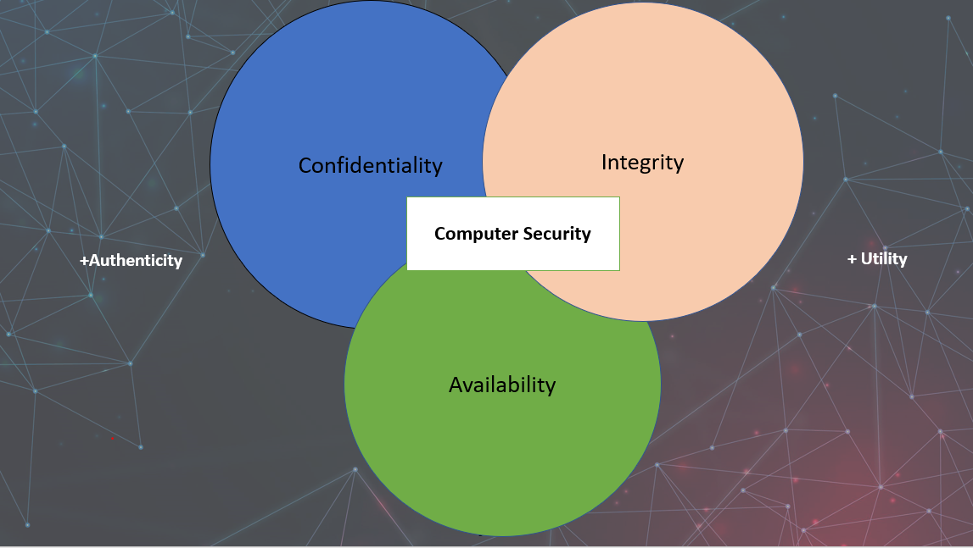  
Fig 1: Elements In Computer Security: Confidentiality |Integrity | Availability (Developed by author)

Confidentiality is the protection of sensitive and protected information from being accessed by unauthorized users. It involves limiting access to certain resources to only those who have been approved and authorized to obtain them. This can be achieved through the use of role-based security measures, which ensure that only authorized users or viewers are able to access specific data. Confidentiality ensures that privileged data is preservedprivate and only made available to those who have been granted access.

Example: One example of confidentiality in computer security is the use of encryption to protect data in transit or at rest. The act of encoding data in a way that it can't be read without using encryptiononlybeaccessed or viewed bysomeoneusing the proper decryption key. This guarantees that even if the data is captured by an unauthorized they won't be able to access its contents as a party.

For example, according to the Special Publication 800-53, Fourth Edition, by the National Institute of Standards and Technology (NIST), "Encrypting data in transit and at rest helps to protect the confidentiality of data and can also protect against tampering with the data" .

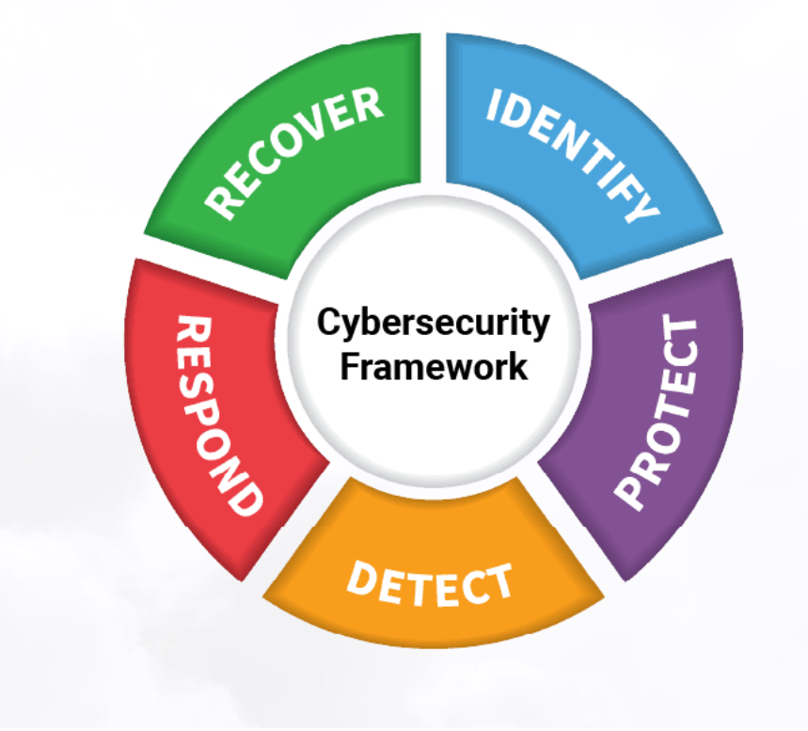

Fig 2: NIST Cybersecurity Framework, DFARS, 800-171(Gaithersburg,MD, 2013)

Integrity refers to the protection of information from unauthorized modification or destruction. This can be achieved through the use of checksums, digital signatures, and other techniques that ensure that data has not been tampered with.

One example of integrity in computer security is the use of checksums or hashes to detect changes to data. A checksum is a value calculated from the contents of a file, and if the contents of the file change, the checksum will also change. By comparing the current checksum of a file to a known, trusted value, it is possible to detect whether the file has been modified.

For example, according to the National Institute of Standards and Technology (NIST) Special Publication 800-53 Revision 4, "Ensuring the integrity of data can prevent unauthorized modification or destruction of data".(Gaithersburg,MD, 2013)

Availability refers to the accessibility of information to authorized users. This can be achieved through the use of redundant systems, load balancing, and other techniques that ensure that systems are available when needed.

Example: denial of service (DoS) attack. A DoS attack is a type of cyber attack in which the attacker floods a server or network with traffic, making it unavailable to legitimate users. This type of attack can be devastating for businesses and organizations, as it can disrupt operations and cause financial losses.(Seymour,Bosworth & Kebay, 2002)

Authenticity**:** In terms of computer security, authenticity is the attribute of being true or legitimate. It is a quality that guarantees a person, thing, or system is who or what it says it is. In computer systems, there are a number of approaches to verify authenticity, including the use of passwords, digital certificates, and unique identifiers.(Gaithersburg,MD, 2013)

Utility relates to a security measure's value or usefulness in computer security. An unnecessary security measure that does not benefit the system or its users is not a good security measure.

The usage of digital certificates is one illustration of a security technique that is both reliable and practical. A device, user, or system's authenticity can be verified using digital certificates, which are issued by a certificate authority (CA), a dependable third party. Digital certificates are digitally signed by the CA to confirm their legitimacy and contain specific identification data, such as a public key. They help to build confidence in online transactions and defend against man-in-the-middle attacks.

Multi-factor authentication is another illustration of a security technique with both validity and usefulness (MFA). To access a system, MFA requires users to supply several types of authentications, such as a password and a one-time code given to their phone. For the protection of sensitive data and systems, this security measure provides an additional layer of defense against unwanted access.(Gaithersburg,MD, 2013)

Countermeasures**:** Another important concept in the field of computer security is the "risk management" approach, which involves identifying and evaluating potential threats, assessing the possibility, effect, and implementation of such threats appropriate countermeasures to reduce the dangers. This strategy is based on the notion that it is not practical or cost-effective to eliminate all risks, but that it is possible to manage and reduce them to an acceptable level.(Stanislav & Williams, 2014)

In order to strengthen their computer security, Need4Help should also consider implementing user access control management measures. This may include implementing strong password policies, implementing two-factor authentication, and regularly reviewing and revoking access privileges for users who no longer need them. These measures can help to prevent unauthorized access to sensitive data and resources, as well as reduce the risk of data breaches due to weak or easily guessable passwords.

Conclusion: Computer security components work to ensure the secrecy, authenticity, availability, usability, and integrity of computing frameworks and their components. Hardware, software, and data in a computing system are all vulnerable to assaults. These three, as well as their interactions with one another, are helpless against flaws in computer security. A system's vulnerabilities can be used by people and systems interested in compromising it.

Task 2: Computer Security Issues:

Computer security is a critical issue in today's interconnected world, as cyber threats have the potential to compromise sensitive data and disrupt business operations. One key concept in maintaining computer security is threat intelligence, which involves collecting, analyzing, and disseminating information about potential threats to inform the development of appropriate preventive measures and incident response plans.(Maryville, 2022)

# Threat Intelligence

Information concerning potential dangers to an organization is gathered, examined, and shared through the process of threat intelligence. It is a crucial part of a comprehensive computer security plan because it enables businesses to recognize potential vulnerabilities, take steps to minimize them, and successfully deal with online threats.(Kaspersky, 2023)

Threat intelligence is significant for several reasons:

Prevent data loss**:** Organizations can identify cyber risks and stop sensitive data from being released through data breaches by implementing a well-structured CTI program.

Provide direction on safety measures**:** In order to help organizations put security measures in place to defend against future attacks, CTI identifies and analyzes risks. By doing so, it can detect patterns hackers utilize.

Inform others**:** Every day, hackers develop their skills. Cybersecurity specialists share the strategies they have observed with their peers in their community to build a collective knowledge base to combat cybercrimes in order to stay current.

Compliance: Threat intelligence can assist firms in identifying and addressing any vulnerabilities that could jeopardize their compliance with various security standards, like PCI DSS and HIPAA, which are mandated by many organizations.(Kaspersky, 2023)

# Who benefits from threat intelligence?

Many different types of organizations, including enterprises, nonprofits, governmental bodies, and others, can benefit from threat intelligence. Organizations that handle sensitive data or are at a high risk of cyberattacks, such those in the financial, healthcare, and defense industries, should pay particular attention to this.

Threat intelligence life cycle**:**

The process of gathering, examining, and disseminating threat intelligence is referred to as the threat intelligence life cycle. Typically, this entails the following actions:

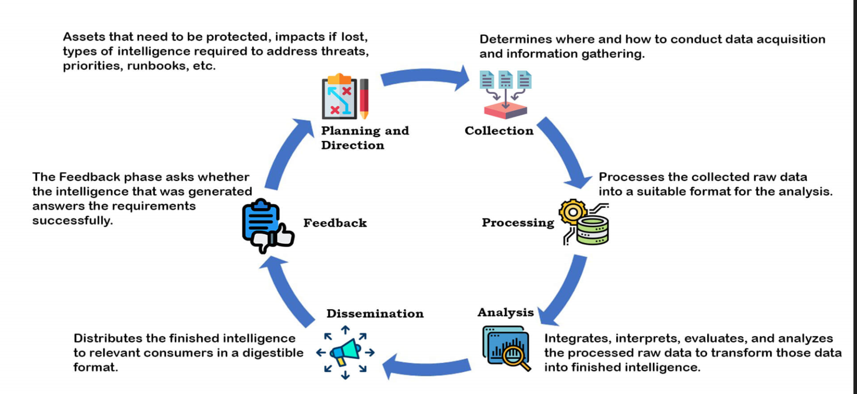

Fig 3: Six Stages of Threat Intelligence of life cycle (chowdhury, 2019)

It is crucial to take a holistic approach that emphasizes threat intelligence as a crucial component in order to address the computer security concerns Need4Help is now facing. Strong user access controls, regular risk assessments, and the implementation of appropriate security measures like firewalls and intrusion detection systems should also be taken into account. Adopting a framework like the National Institute of Standards and Technology (NIST) Cybersecurity Framework, which offers a structured method for identifying and managing cybersecurity threats, may also be advantageous.(chowdhury, 2019)

Threat Modelling Methods: Organizations can discover and rank potential threats to their systems, applications, and data by using the technique of threat modeling. It entails determining the assets that require protection, the risks and threats that may impact such assets that these threats might take advantage of. Organizations can employ a variety of techniques for threat modeling, including:(Reciprocity, 2022)

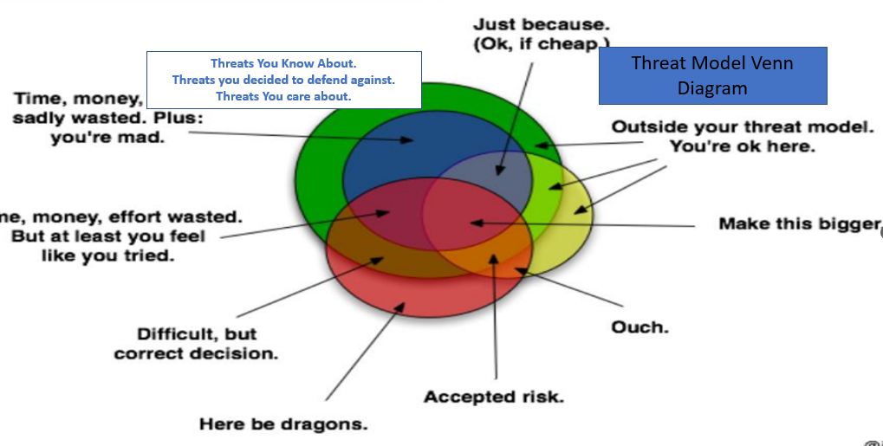

Fig 4: A Threat model Venn diagram Source.( Schaumann, 2022)

Stride Threat Model**:** Identity theft, data manipulation, Rejection, Information Sharing, Refusal of Service, and Privilege Elevation all go under the umbrella term STRIDE, which was created by Microsoft.

It is now the most developed threat modeling technique, and both cyber-only and cyber-physical systems respond well to its use.

STRIDE analyses the in-place system detail design and models it. By creating data-flow diagrams (DFDs), it is used to identify system elements, events, and the system's boundaries. Based on its name, it also applies a broad range of recognized dangers.(Reciprocity, 2022)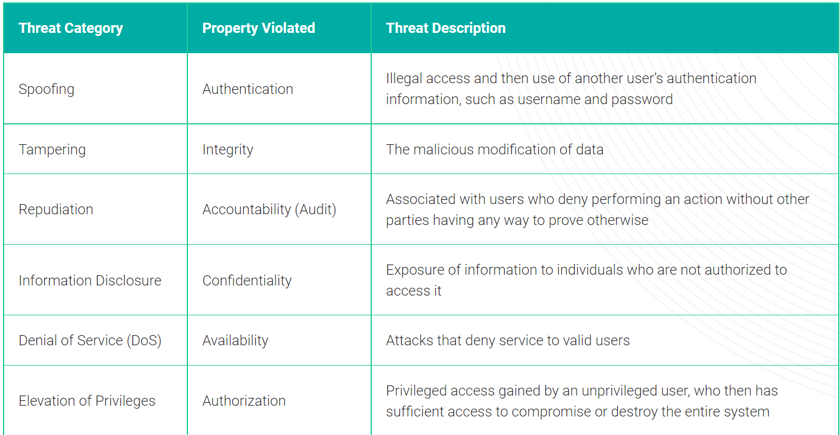

Table 1: 6-Steps of Stride. (River, 2022)

DREAD Threat model**:** The efficacy of this strategy as a threat model has been questioned, hence it is the last on this list. Due to erratic ratings, Microsoft stopped using DREAD in 2008.

This method, developed by the security firm BeyondTrust, involves assessing threats according to their potential for harm, reproducibility, exploitation, affected users, and discoverability.(Kost, 2022)

The DREAD model rates each security risk according to one of five categories:

Damage Potential**:** Rates the amount of damage a vulnerability-based attack can do.

Reproducibility**:** Indicates how simple it is to replicate a cyberattack.

Exploitability**:** Indicates how challenging it would be to carry out a certain cyberattack.

Affected Users**:** Assigns a value to indicate how many users will be harmed if an exploitation spreads widely.

Discoverability**:** Assigns a number based on how simple it is to find a specific threat.(EC-Council, 2022)

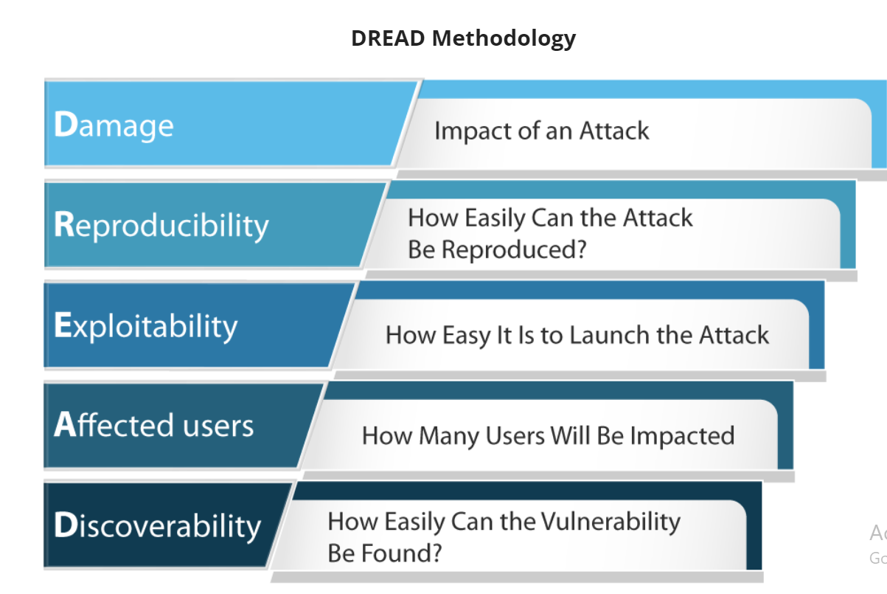

Fig 5: DREAD Methodology. (EC-Council, 2022)

An organization could evaluate the possible repercussions of various cyberthreats, such as data breaches, ransomware attacks, or network disruptions, to construct a dread threat model. They might also think about how likely it is that these threats will materialize, taking into account things like the organization's size, industry, and cybersecurity posture.

The company can assign a "dread score" to each threat based on a combination of these criteria after determining the probable impact and likelihood of each threat. The most serious risks would be given priority for addressing and would get the highest dread scores.

A ransomware assault, for instance, might have a high dread score if it has the ability to significantly disrupt the organization's operations and create financial losses, but a phishing attack, which is more likely to do minor harm, might have a lower score.(Bulao, 2022)

Task 3: - Security Frameworks:

A company should follow a cybersecurity framework, which is a collection of best practices, to manage its cybersecurity risk. The framework's goals are to reduce the company's exposure to cyberattacks and identify the areas where data breaches and other compromising behavior by online criminals are most likely to occur.

Organizations can employ a variety of popular cyber security frameworks to safeguard their computers from both internal and external threat actors. These frameworks often offer advice on the best ways to put in place and keep up efficient cyber security procedures.

Below is a table of reference for different cyber security framework:

Table 2: Security frameworks comparison (Source: Author)



# NIST CSF framework and ISO27001 recommendation for Need4help:

Both the NIST CSF and the ISO 27001 standard offer thorough guidance on designing and maintaining effective cyber security controls, therefore it may be acceptable to take both frameworks into account in the context of the given case. Which framework is chosen will rely on the organization's particular demands and limits as well as any regulatory or compliance standards to which it may be subject.(NIST, 2021)

Need4help must carefully manage and restrict access to their systems and data in terms of user access control management. The usage of authentication and authorization systems, such as user accounts, passwords, and multi-factor authentication, can be used to accomplish this. To make sure that only authorized people have access to the systems and data they need to conduct their tasks, it is also crucial to routinely check and update user access rights.

In order to safeguard against both internal and external threat actors, it is critical for enterprises to have strong and regularly maintained cyber security architecture in place. Organizations may guarantee the privacy, availability, and integrity of their vital information assets by adhering to best practices and routinely monitoring and updating their cyber security measures.

# How does the NIST affect Need4help Charity?

The Cybersecurity Framework (CSF) of the National Institute of Standards and Technology (NIST) is a risk-based framework that offers instructions on how to handle and defend against cyber attacks. It has five primary components: recognize, guard against, detect, react to, and recover. Each of these parts issues supplemented by a number of categories and subcategories that offer detailed instructions on how to set up and maintain efficient cyber security policies.

Adopting the NIST CSF could potentially aid the Need4Help charity in managing and protecting against cyber threats. The company might put stronger cyber security processes and controls in place by adhering to the NIST CSF's recommendations, which could reduce the risk of cyberattacks and data breaches. This could help to safeguard the organization's important data's Confidentiality, Integrity, and Availability (CIA), as well as help stop any financial losses and other unfavorable effects that might arise from a cyberattack.

The NIST CSF is a flexible framework, therefore it might not be appropriate for all businesses, it's crucial to remember that. The organization should carefully analyze its unique requirements and limitations to decide if the NIST CSF is the most appropriate solution in its particular situation. The firm may want to take into account alternate frameworks or techniques to managing and defending against cyber threats if the NIST CSF is not a good fit.

# What happens if a charity is not NIST compliant?

A charity may be more vulnerable to cyberattacks and data breaches if it does not adhere to the National Institute of Standards and Technology's (NIST) Cybersecurity Framework (CSF). Due to non-compliance with the framework, the business may not be able to establish enough controls to mitigate these risks. The NIST CSF offers recommendations on best practices for managing and guarding against cyber threats. This could result in the important data belonging to the charity's Confidentiality, Integrity, and Availability (CIA) being compromised, which could have a severe impact on the charity's finances, reputation, and other factors.

Additionally, if the charity is required to use the NIST CSF by regulatory or compliance rules, breaking those rules could result in fines, penalties, or other enforcement actions being taken against the organization.

Overall, it is crucial for charities to take into account their demands for cyber security and to put in place the right measures to reduce the risks associated with cyberattacks and data breaches. The confidentiality, integrity, and availability of the organization's crucial data can be ensured by adopting the NIST CSF or another acknowledged cyber security framework.

TASK 4: ACL – Access Control List

Here is a rundown of the various ACL like User Account Management objects that are offered by Active Directory, along with descriptions of how they might be used to enhance security:

1. User objects**:** In Active Directory, user objects stand in for user accounts and hold details like the user's name, email address, and password. To prevent unwanted access, it's critical to implement strict password regulations and often change user account passwords. (Microsoft TechNet, n.d.).

2. Group objects**:** To grant access rights to network resources like shared folders or printers, such as group objects that represent groupings of user accounts. Organizations can guarantee that only authorized individuals have access to sensitive resources by regulating group membership and permissions (Microsoft TechNet, n.d.).

3. Default groups**:** The "Domain Admins" group in Active Directory, for example, has complete power over the domain, and the "Enterprise Admins" group has complete control over the entire forest. In order to guarantee that only individuals with permission have access to critical resources, it is crucial to manage these groups and memberships appropriately. (Microsoft TechNet, n.d.).

4. Securing administrative accounts**:** To prevent unwanted access, it is crucial to set robust, one-of-a-kind passwords for all administrative accounts and to rotate them on a regular basis (Microsoft TechNet, n.d.). Two-factor authentication (2FA) can be used to increase security by requiring a second form of identification in addition to the password, such as a code delivered to a phone. (Microsoft TechNet, n.d.).

5. Group Policy**:** Active Directory's Group Policy feature enables administrators to define policies for users and computers inside a domain. Organizations can enforce rules like password complexity and expiration, computer settings like background screen change, add and remove program settings as well as manage which users have access to specific resources, by establishing Group Policy. (Microsoft TechNet, n.d.).

6. Configuring users and groups**:** An essential step in safeguarding an organization's computer systems is making user accounts for each employee and giving them the proper permissions and access rights. When setting up user accounts, it's crucial to adhere to the concept of least privilege, which states that you should only give users access that is absolutely necessary for them to carry out their tasks. This lessens the likelihood of intentional or unintentional resource misuse (Microsoft TechNet, n.d.).

In conclusion, Active Directory offers a variety of objects and tools, such as User and Group objects, default groups, Group Policy, and the ability to configure users and groups, for managing user accounts and permissions. Organizations can increase the security of their computer systems and avoid security breaches by correctly deploying these elements.

# Demonstration:

Here is a stepwise demonstration of installing Windows Server 2019 on Oracle VM virtual box:

Installing Virtual Machine:

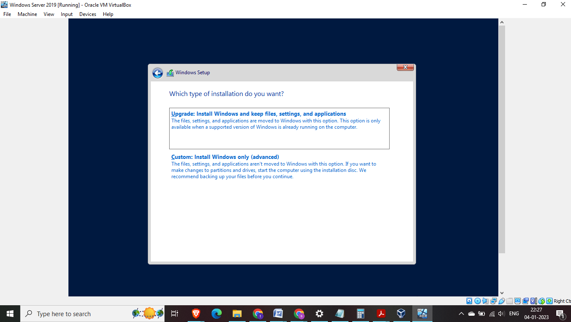

Fig 6: Choose custom option to select virtual hard define earlier

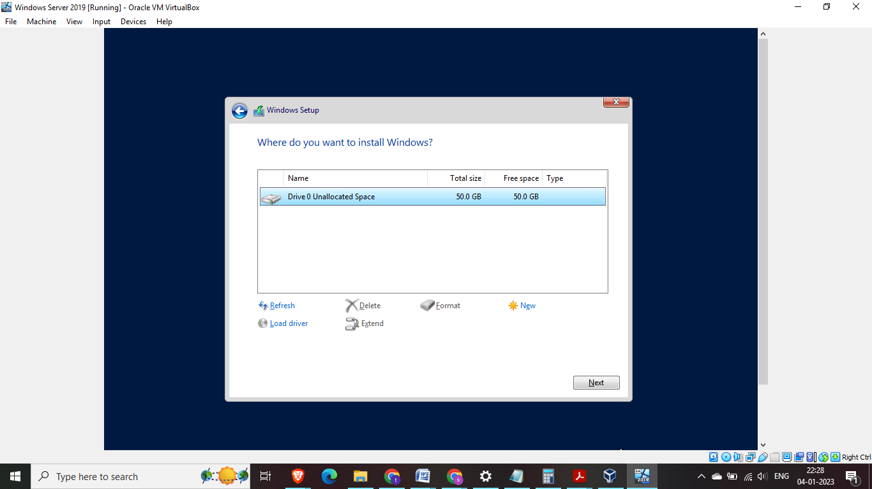

Fig 7: Select the virtual drive defined earlier

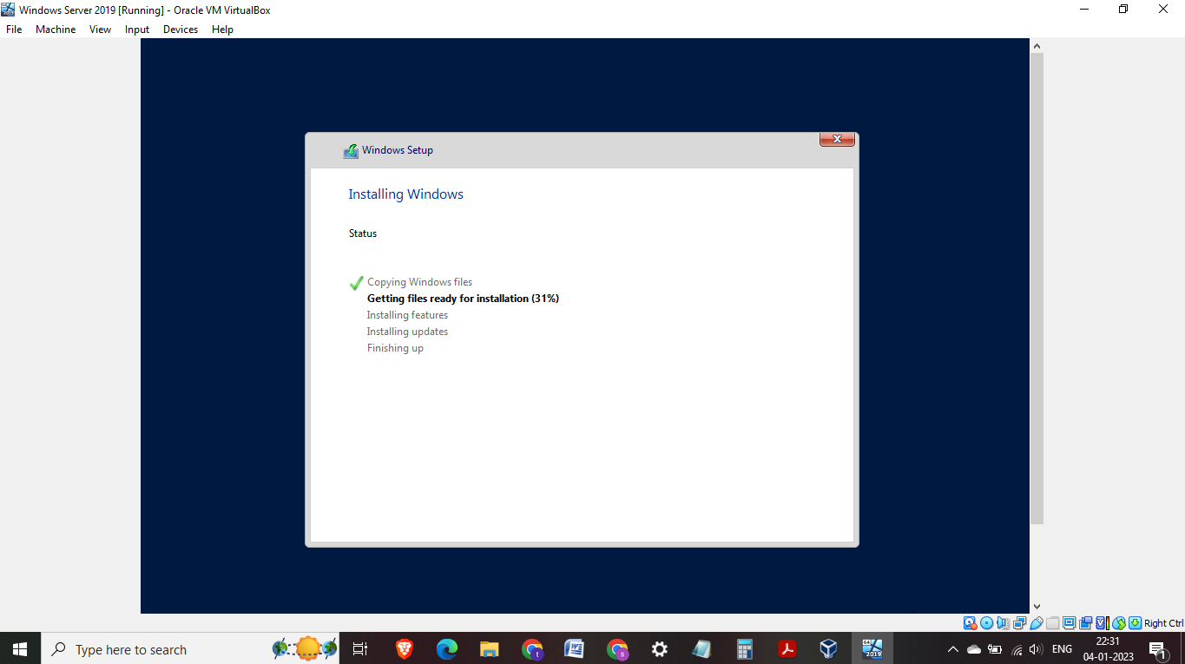

Fig 8:Installation in progress

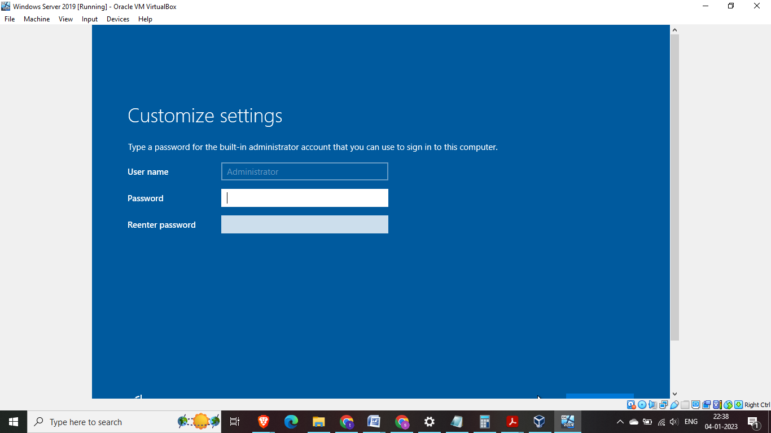

Fig 9: Select Password

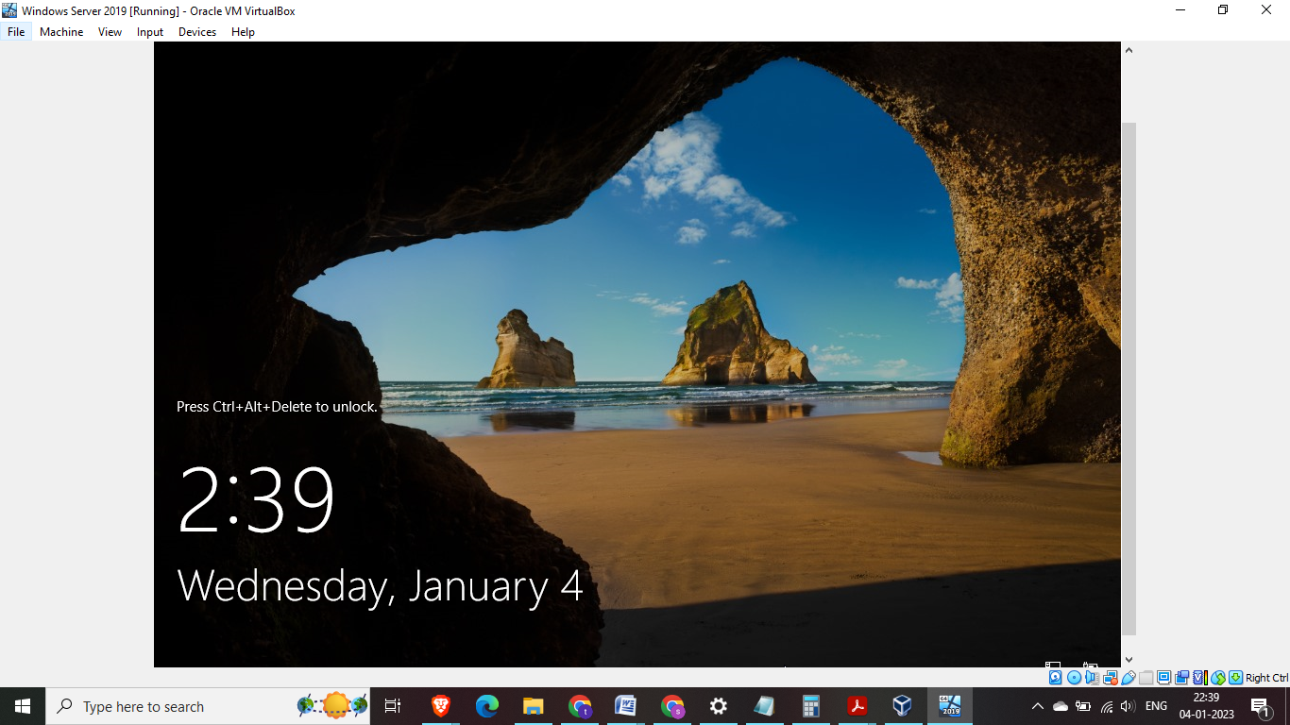

Fig 10: Main page after installation

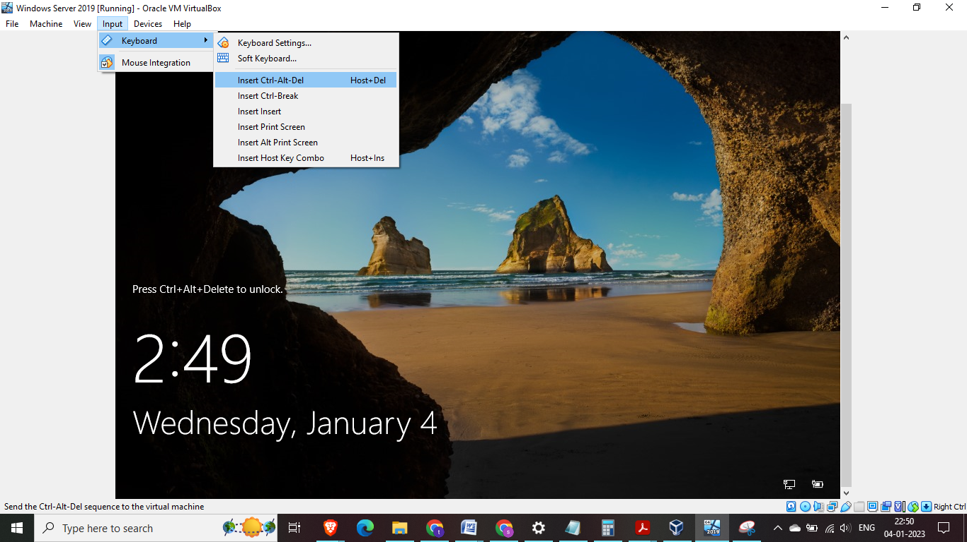

Fig 11: To use Ctrl+Alt+Delete in Virtual box machine either use Menu >Input >Insert Ctrl+Alt+Del as shown above or use Shift+Ctrl+Alt+Del in keyboard either will work

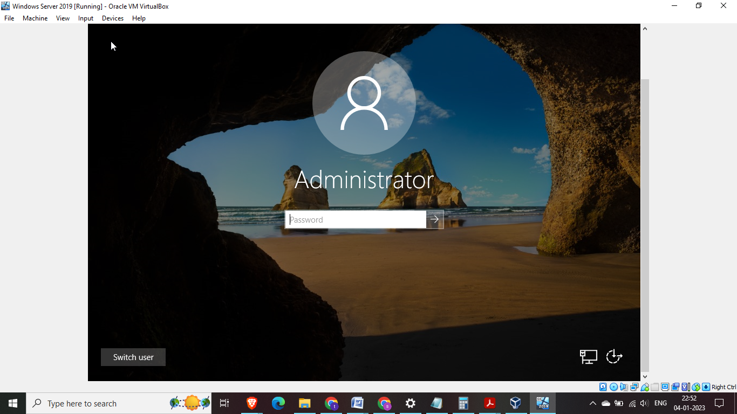

Fig 12:Enter password as setup earlier

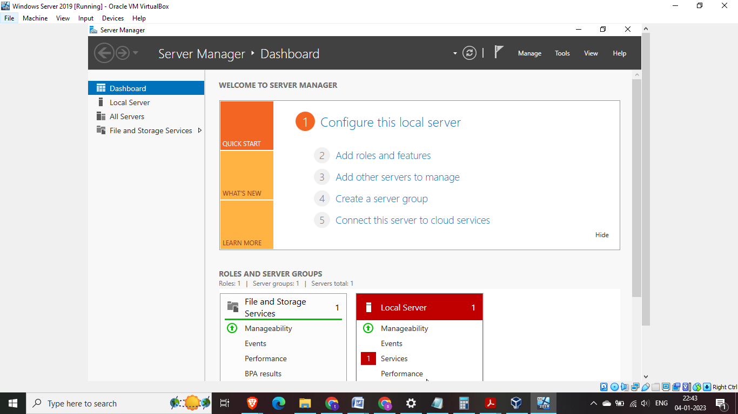

Fig 13: Search for server manager and open – Server dashboard is visible as we open server manager

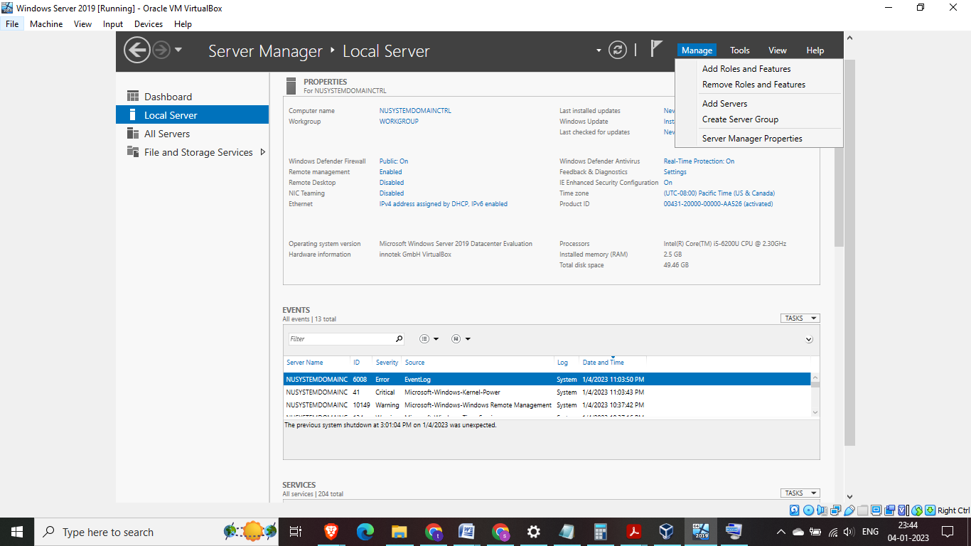

Fig 14:Click on Manage > add Roles and features

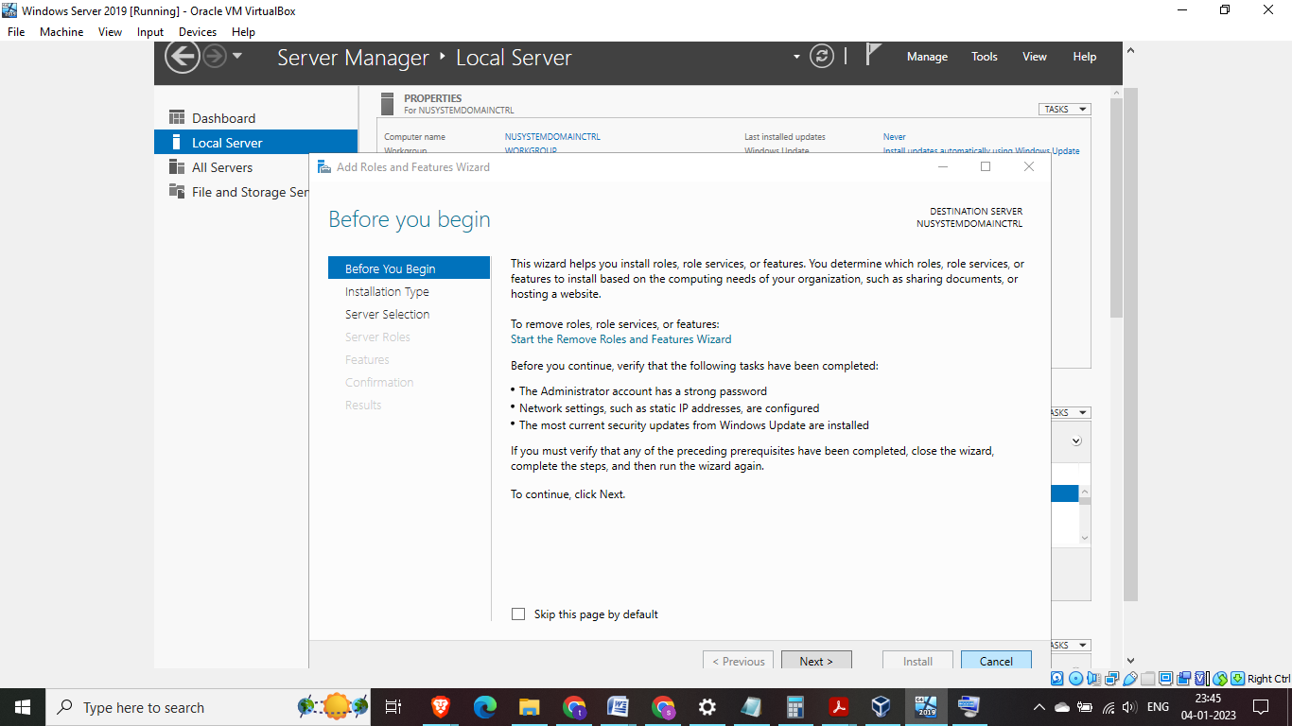

Fig 15: This page tells us what the wizard does and also reminds us of important tasks to carry out >Read the details and click next

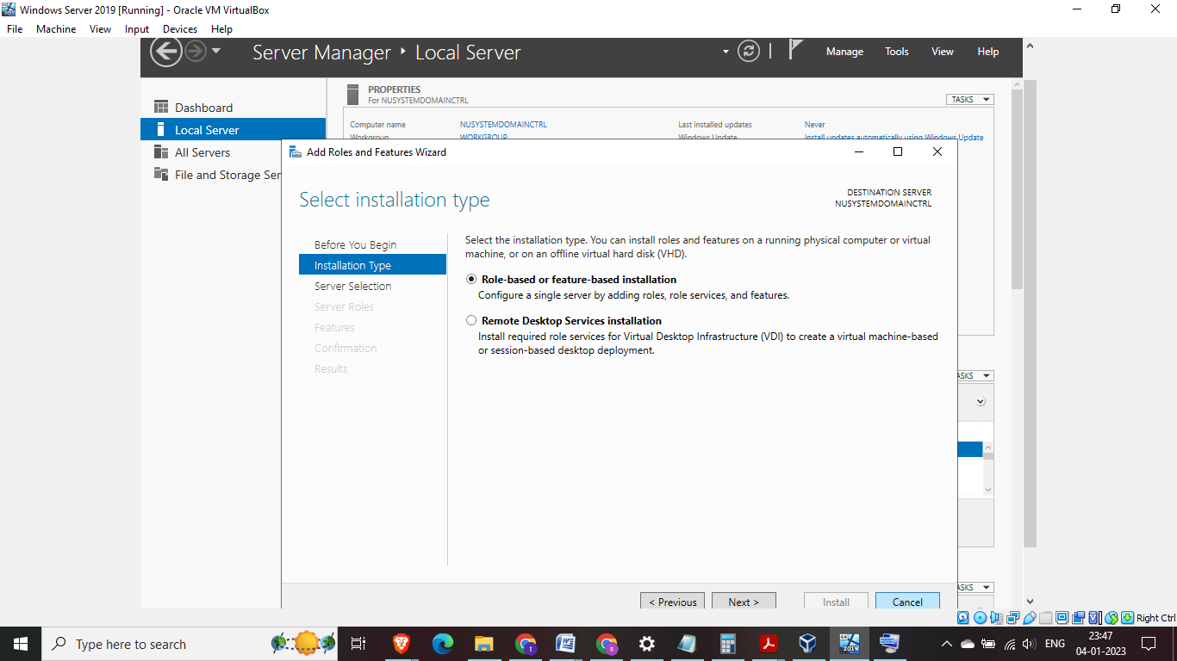

Fig 16: Select Role based or feature based installation

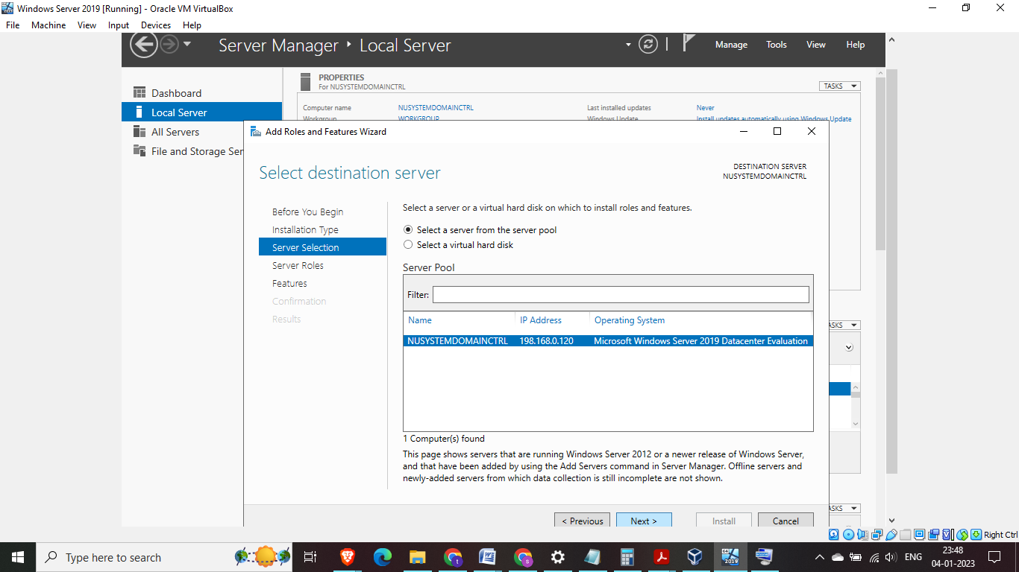

Fig 17:Server manager allows us to manage multiple servers, in this case there is only one server configured hence select and click next

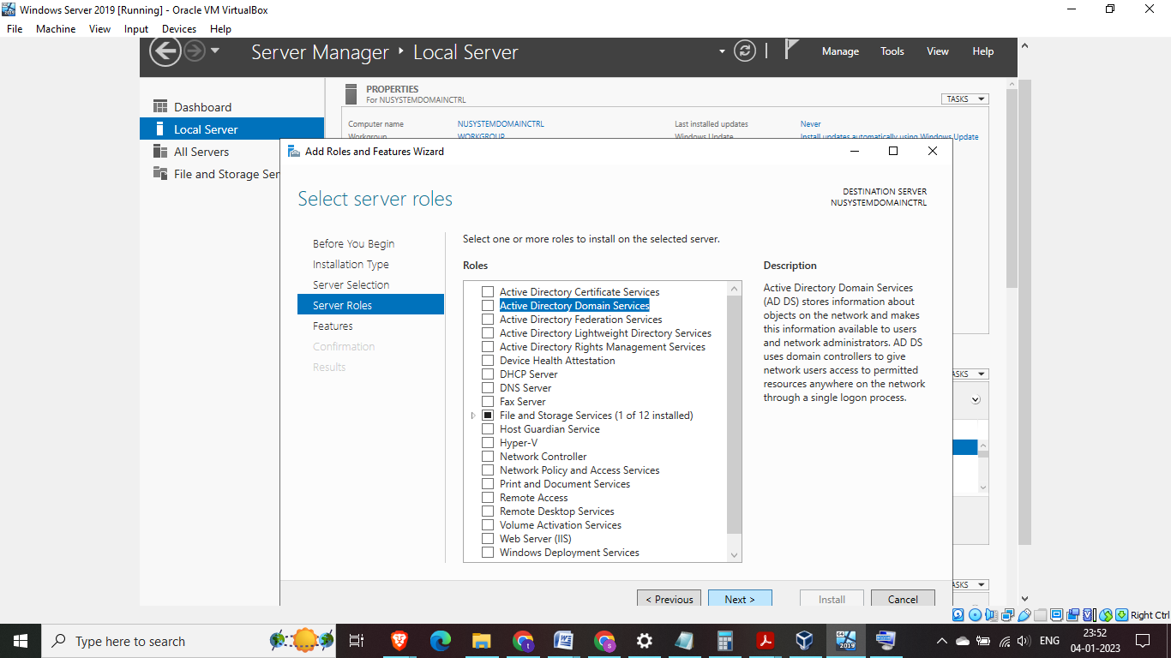

Fig 18: The installation prompts to select the role or roles > in this case we select Active Directory Domain Services

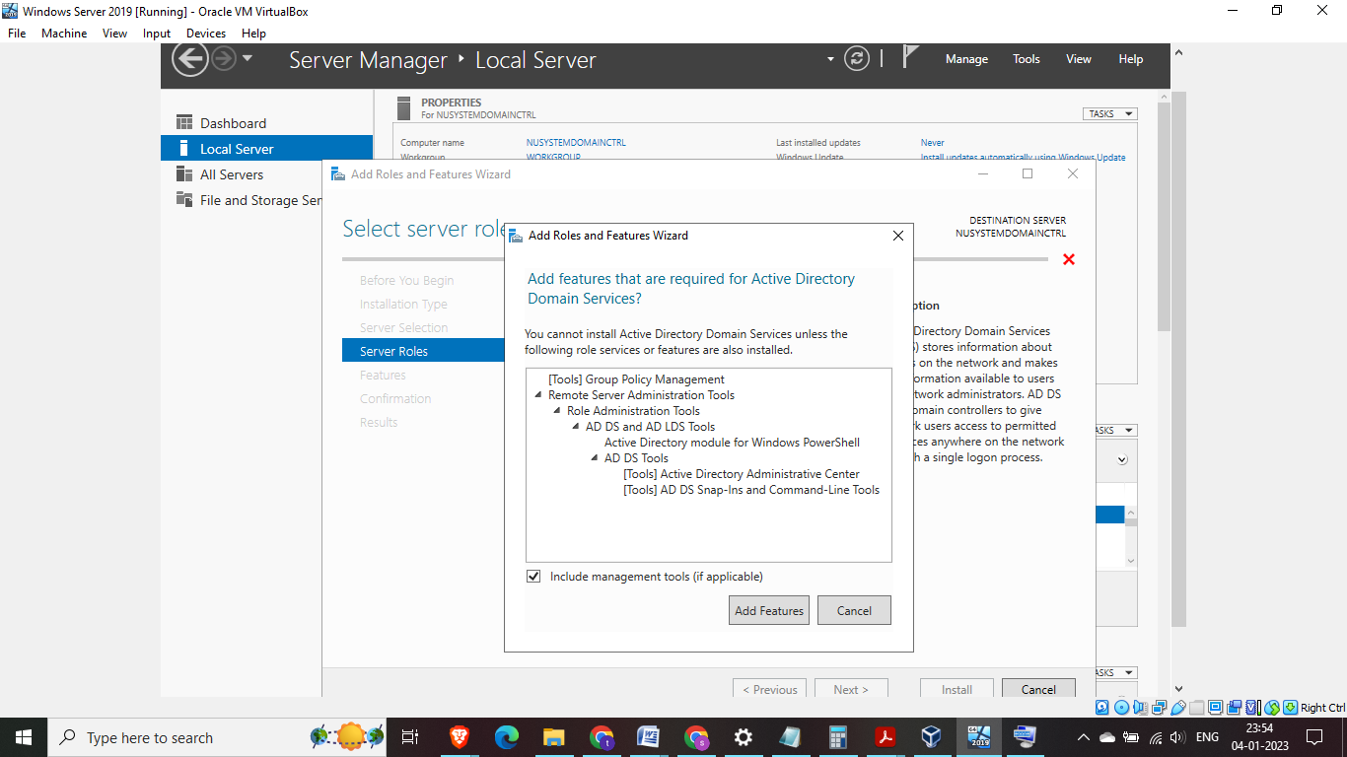

Fig 19: System prompts to add features required by Active Directory Domain Services > Click on add features

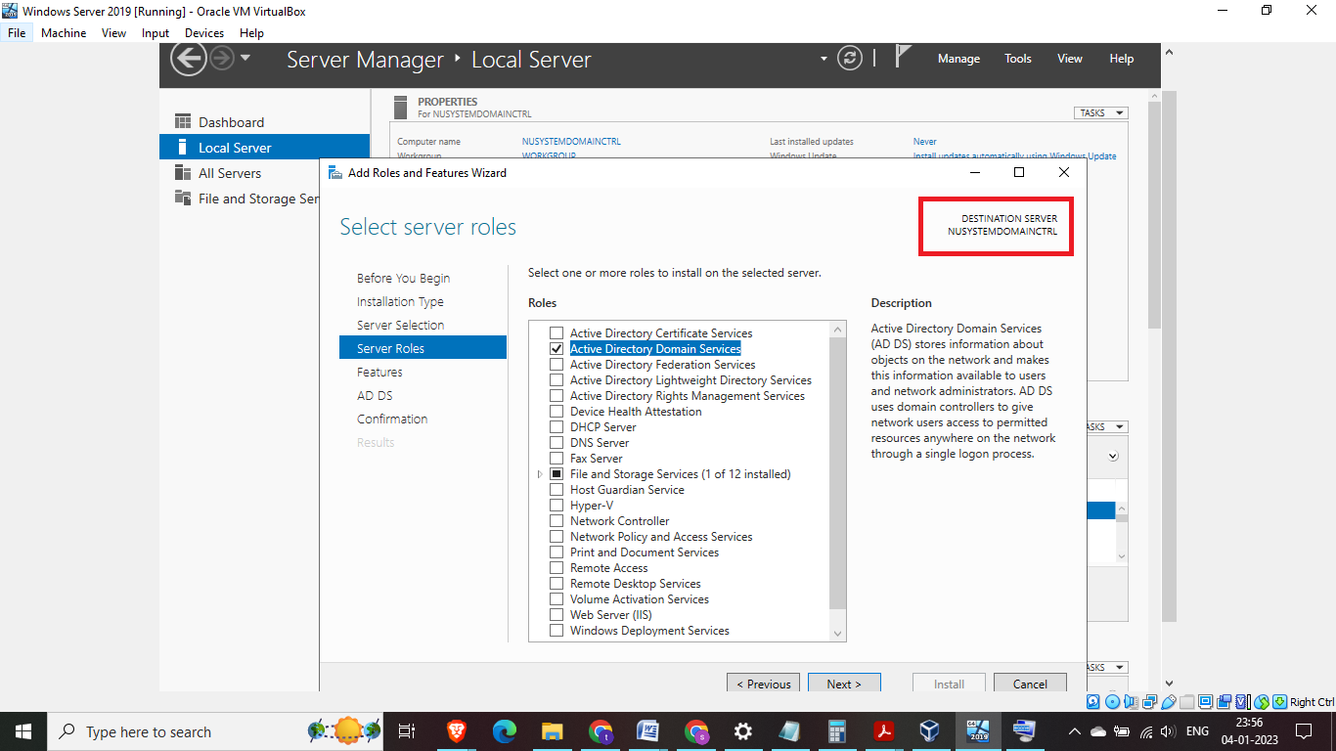

Fig 20: Notice on top right corner it shows the server we are installing the features on > click next

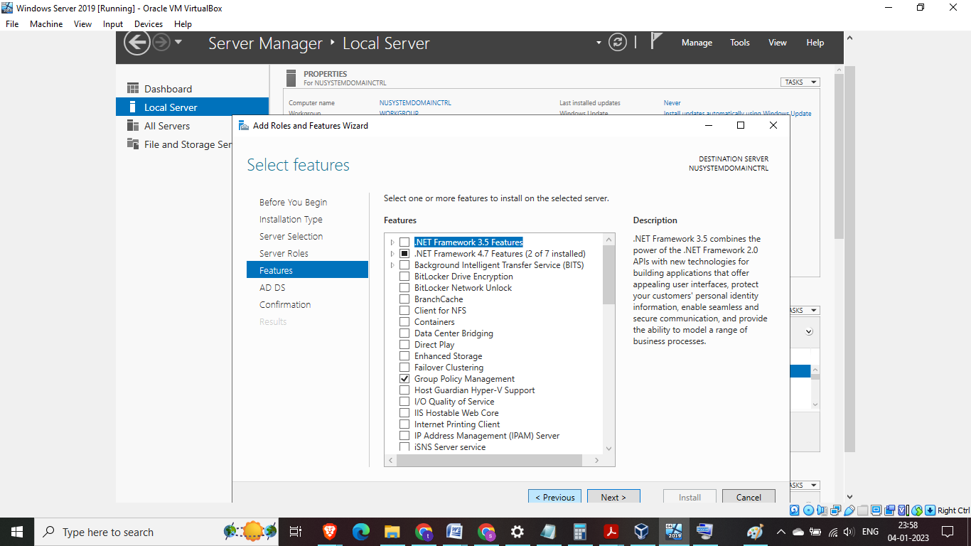

Fig 21: On this screen Group Policy Management has been selected automatically, click next

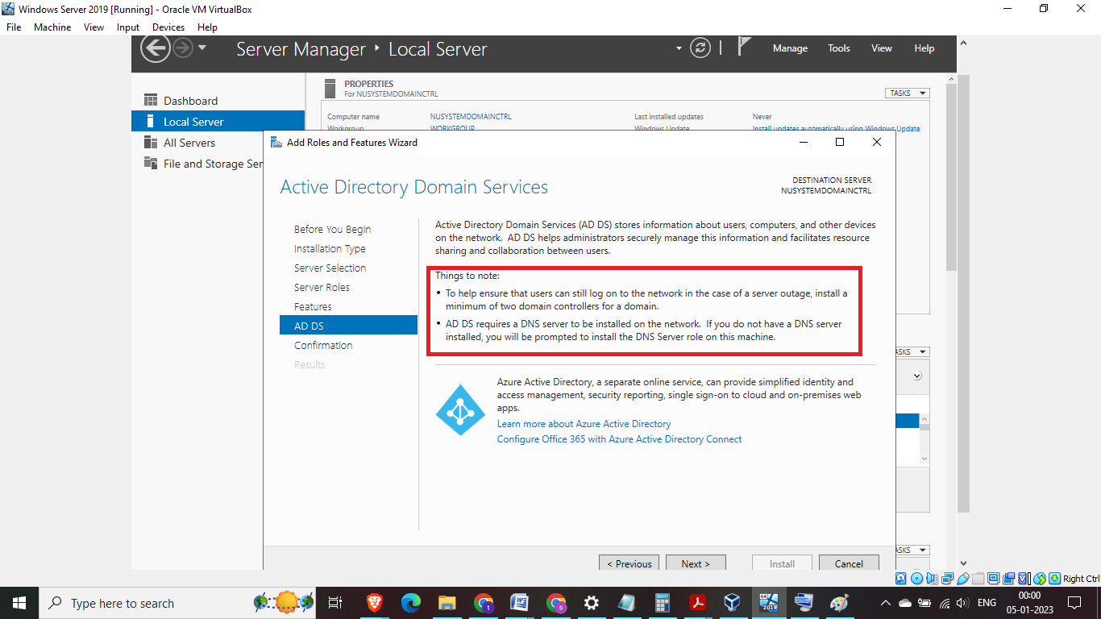

Fig 22: On this screen key points to note are mentioned around best practices > Click next

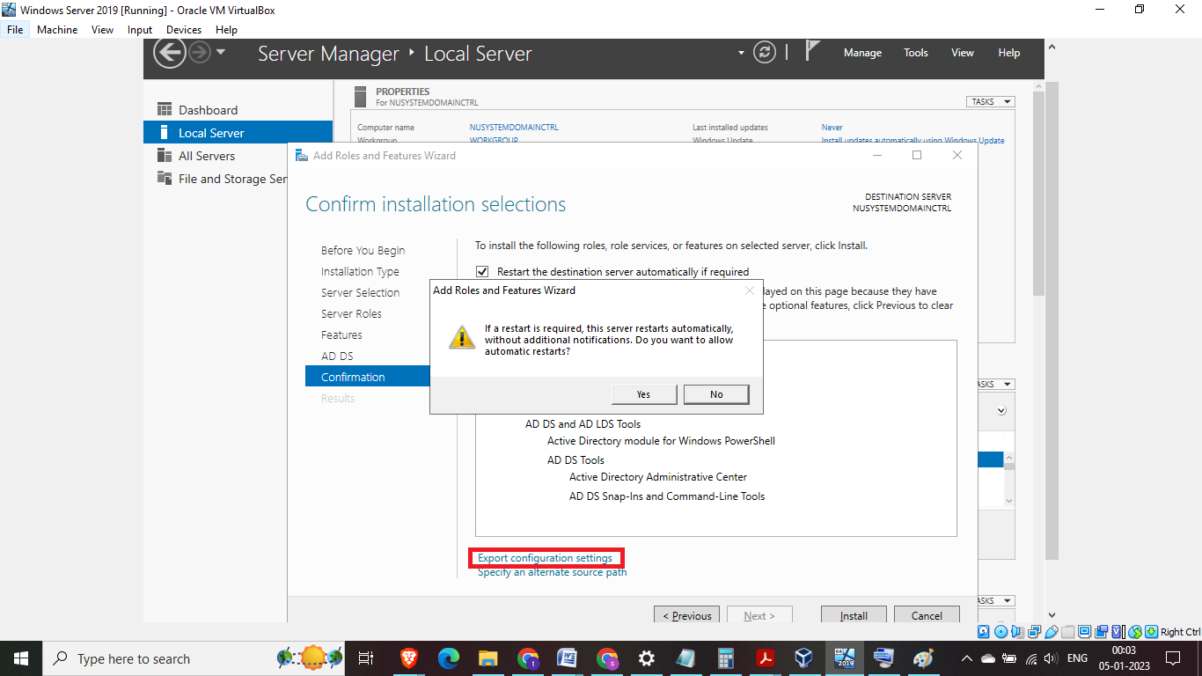

Fig 23: This page is the confirmation on all selection, click on the check box for automatic restart and also below (highlighted portion) the wizard gives an option to highlight Export configuration setting incase multiple servers need to be setup with same configuration > then click on install

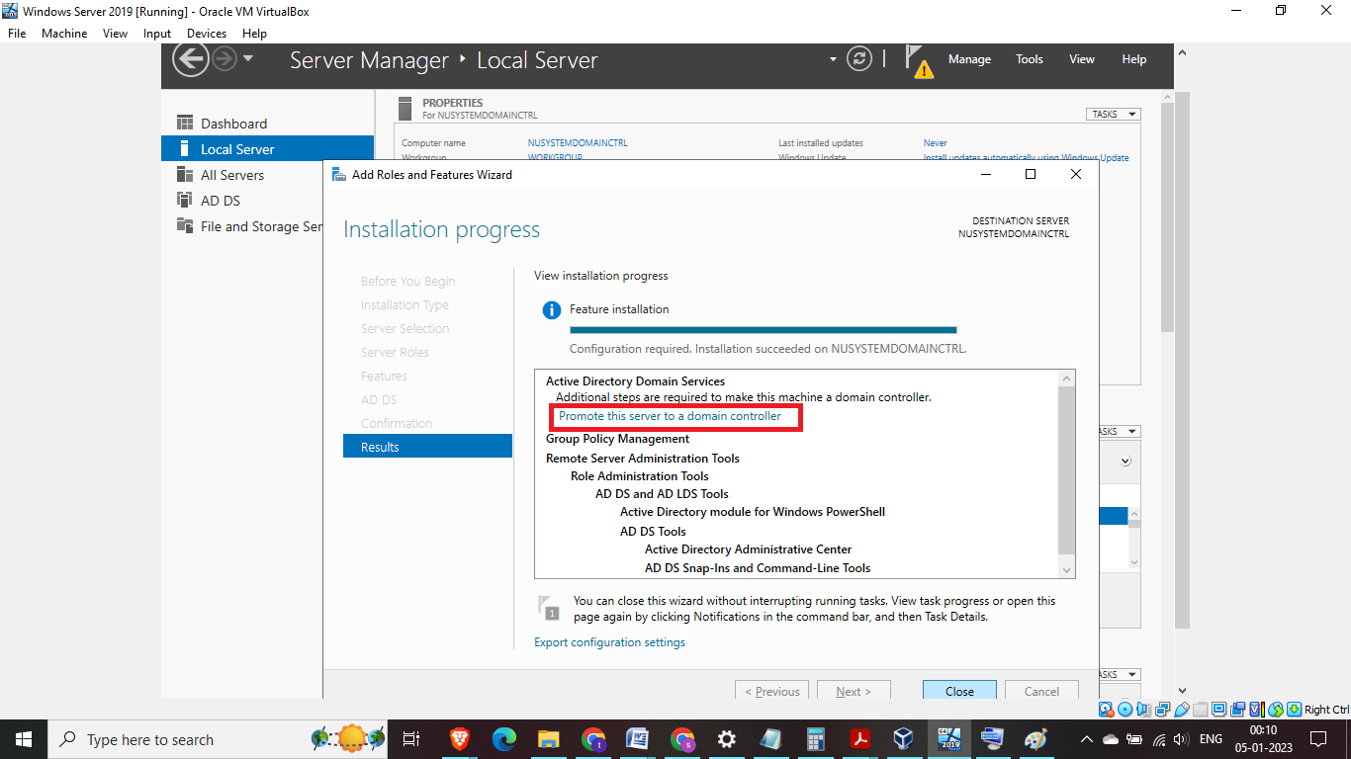

Fig 24: Installation completion will be prompted by steps required to make this machine a domain controller > click on highlighted link “Promote this server to a domain controller”

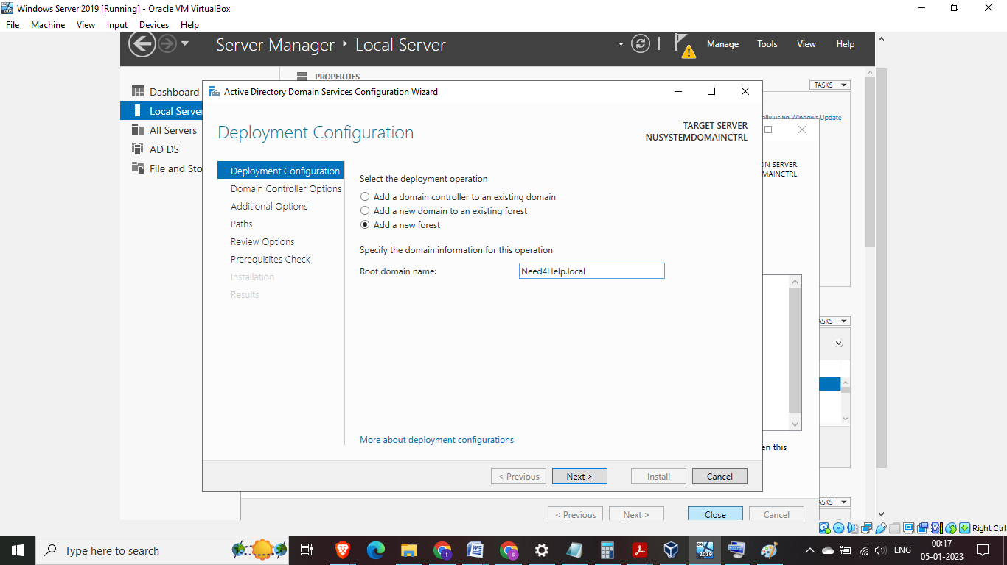Fig 25: We need to add a new forest name > in this case it is Need4Help.local (note : Best practices in production environment is to have root domain should also have a prefix of company domain name

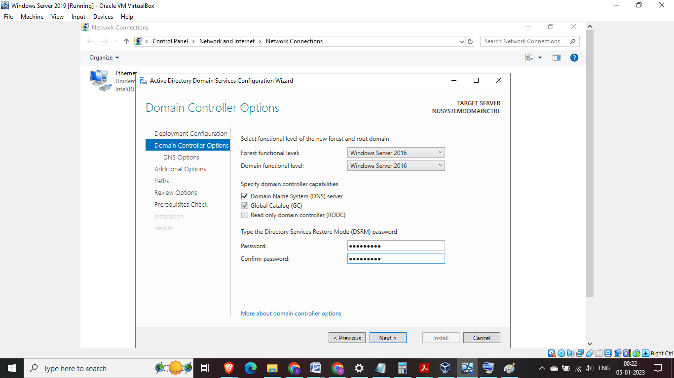Fig 26: Forest functional level and Domain functional level needs to be set up, the domain functional level needs to be set a level higher or equal to forest functional level. In this case since we are not dealing with any legacy system therefore both are set to Windows Server 2016. DNS server is required for Active Directory and Global Catalog Server(GCS) is selected and greyed out because atleast on GCS is required.  
Read Only Domain Controller is unchecked and greyed out because the first domain controller cannot be read only. We need a password for Active Directory restore mode, this is very important incase we need to perform an active directory recovery

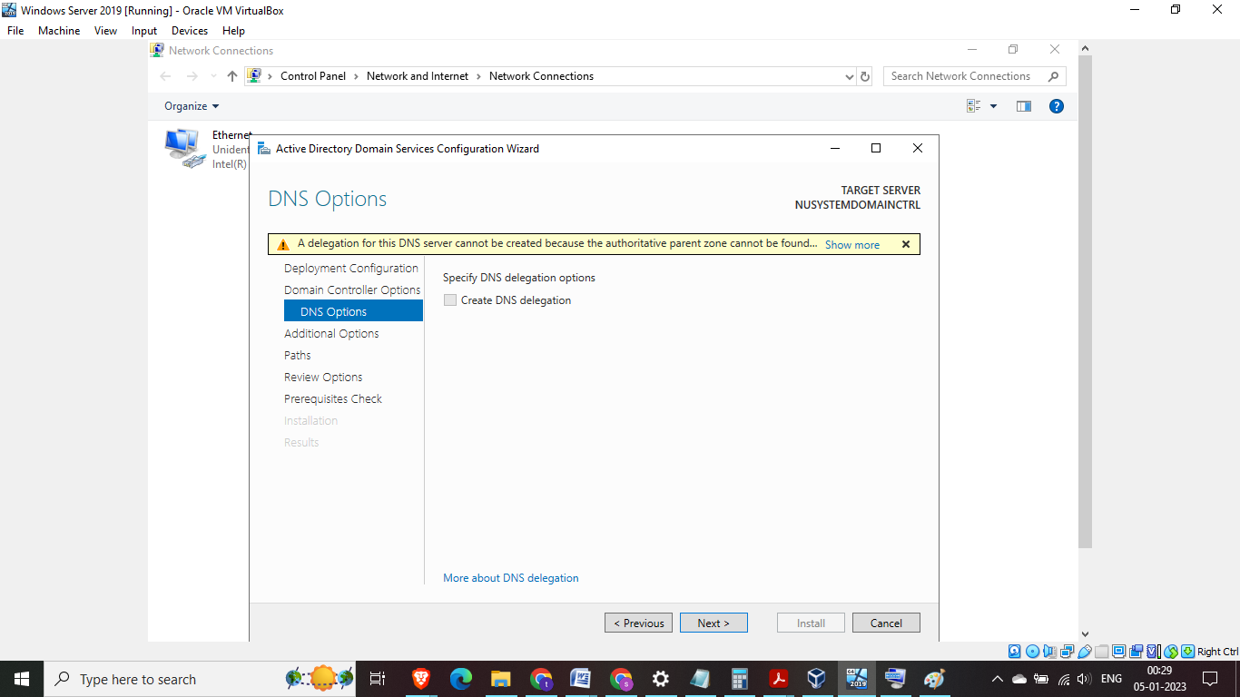Fig 27: A warning sign appears as there DNS has not been installed yet we click on next

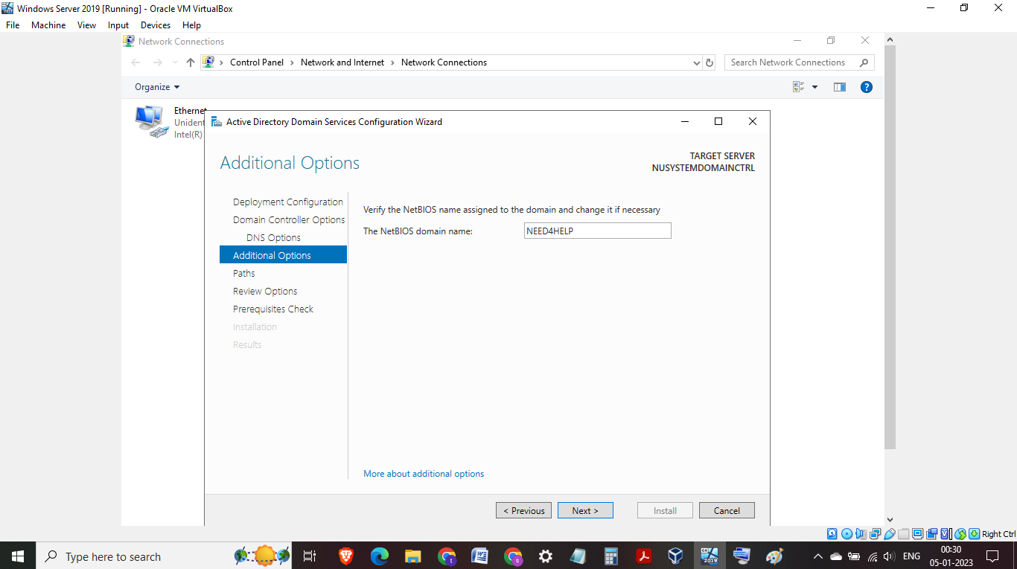Fig 28: NetBIOS domain name is verified, we have an option to change the name

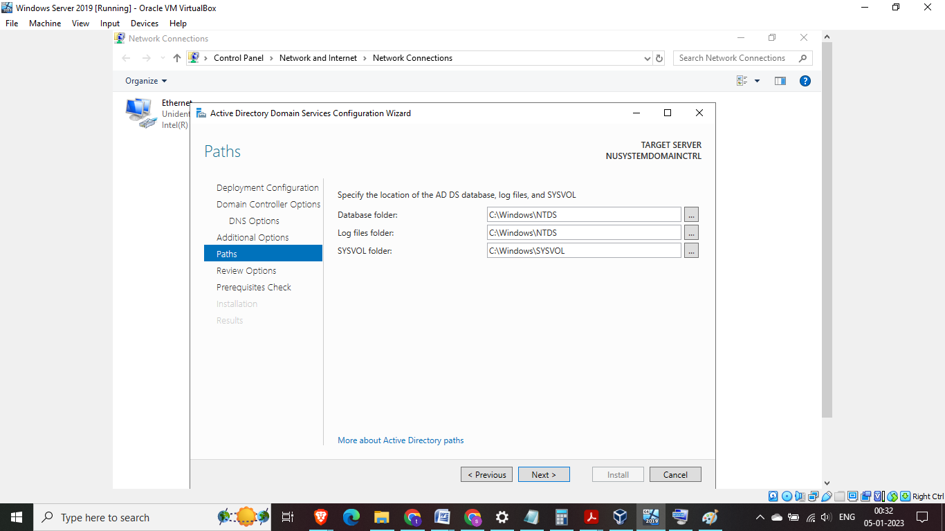Fig 29: This is check on the location of files for NTDS and SYSVOL

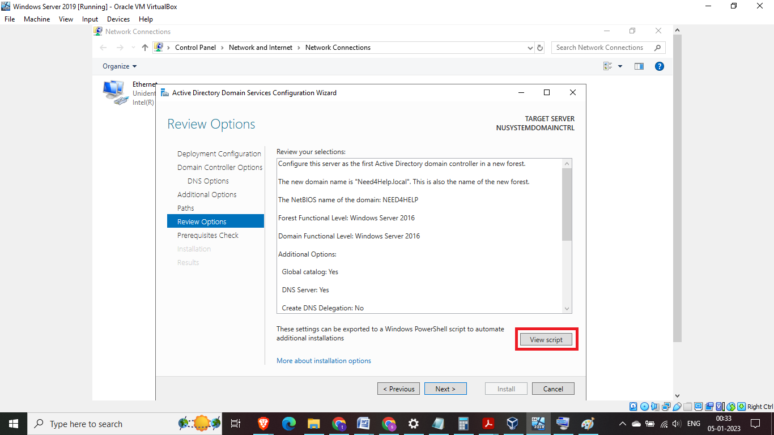Fig 30: Review option screen is to review all the previous selections we have specified. The setting can also be exported as powershell scripts to automate additional installations > Click next

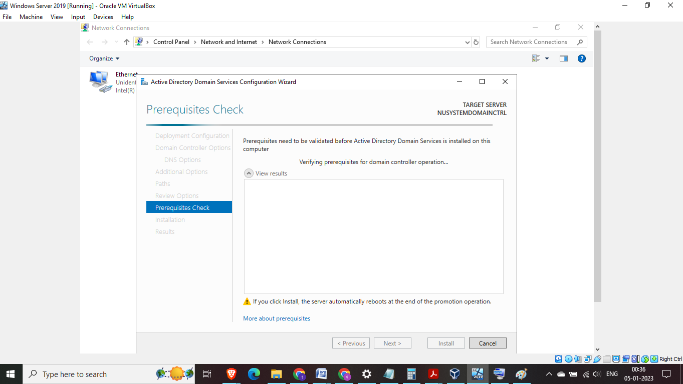

Fig 31: Prerequisite check is run by the wizard

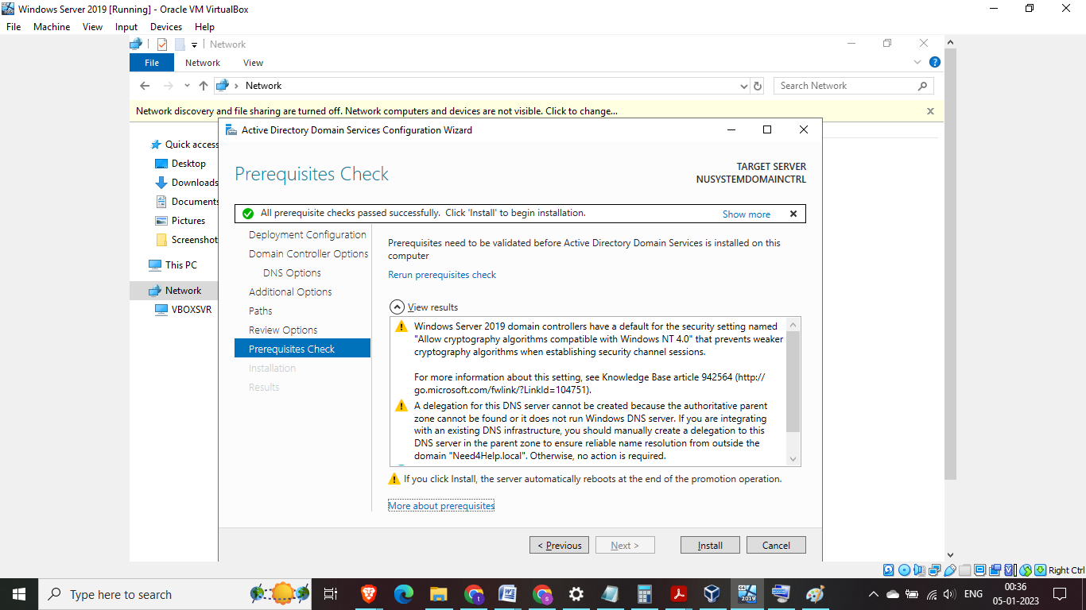

Fig 32: Prerequisite checks has been completed successfully and proceed with install. (Note: there are some warnings which is to be expected with brand new Active Directory install)

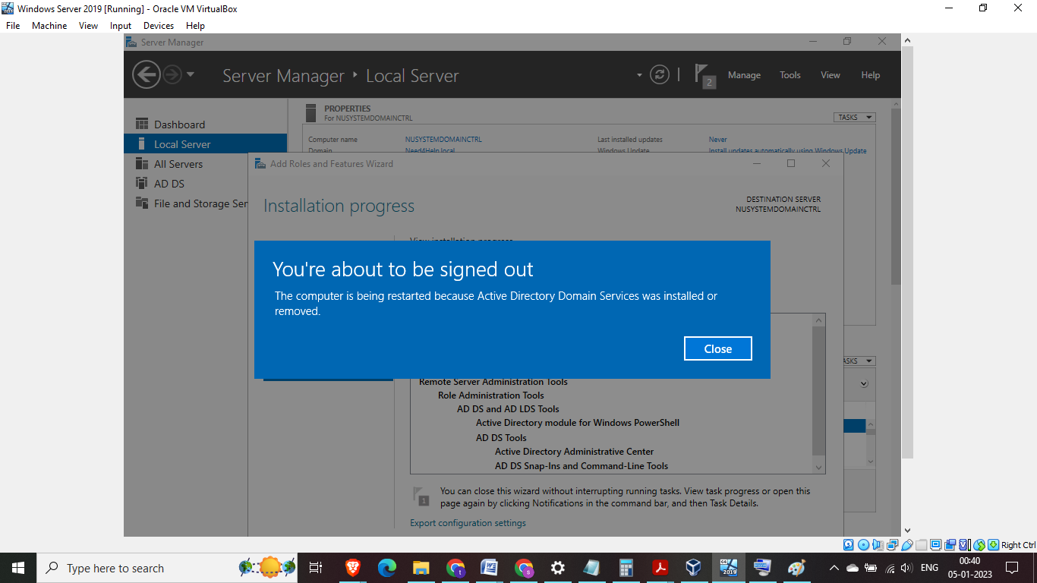Fig 33: System will reboot as the installation is complete

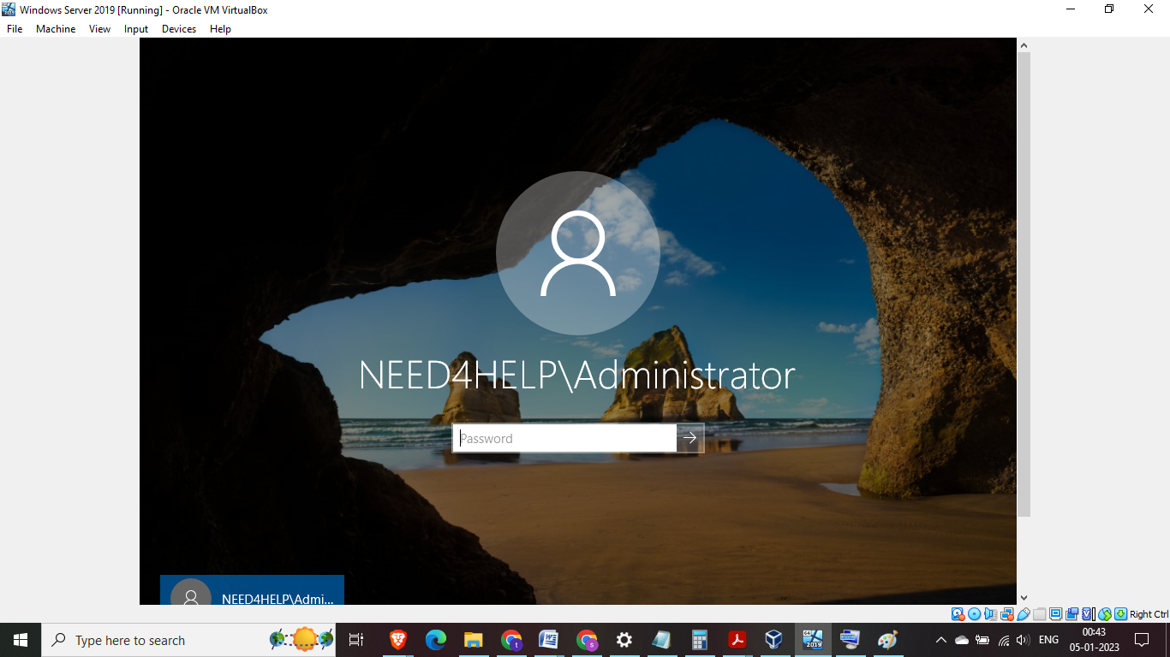

Fig 34: Notice now the Domain name also appears as a prefix to administrator

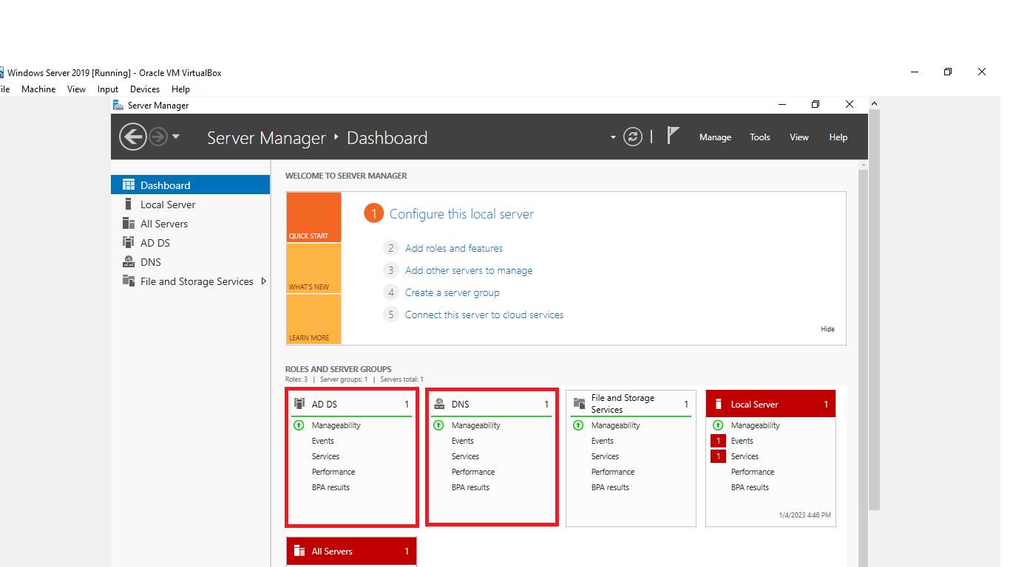

Fig 35: The server manager dashboard now has an AD(Active Directory) tile and DNS tile

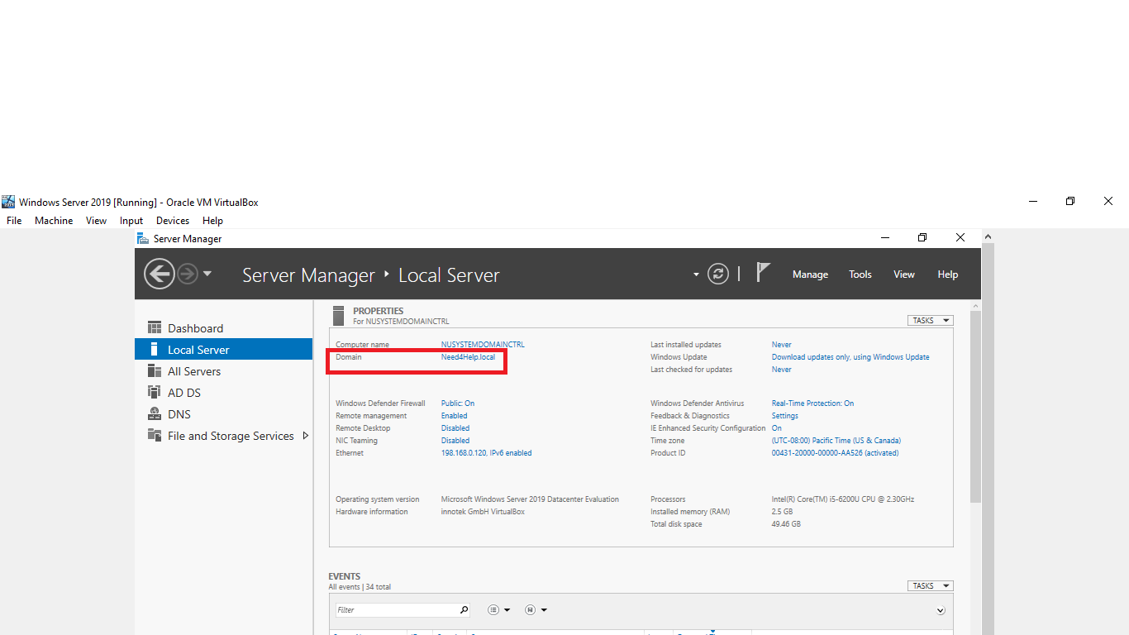

Fig 36: Under local server the domain now corresponds to the local domain (Need4Help.local)

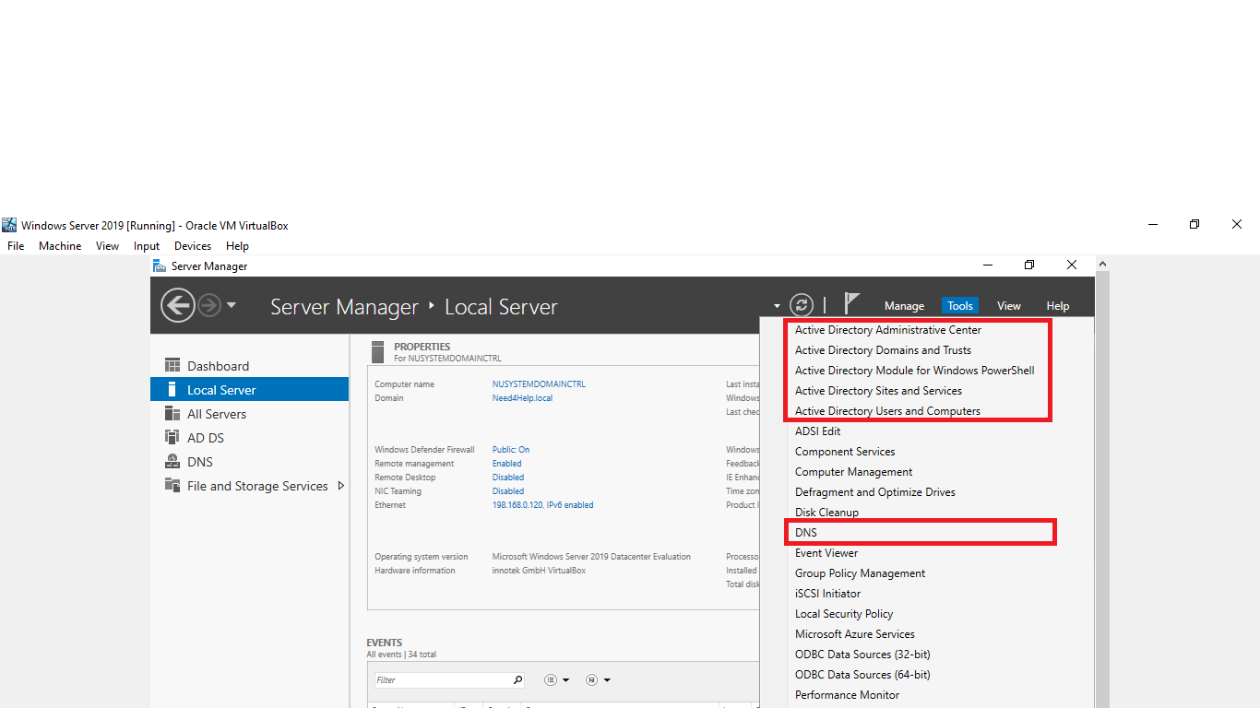

Fig 37: Under tools we can see a number of Active Directory management tools available and also DNS. Active Directory has been successfully installed and server is a domain controller

## New Dept creation:

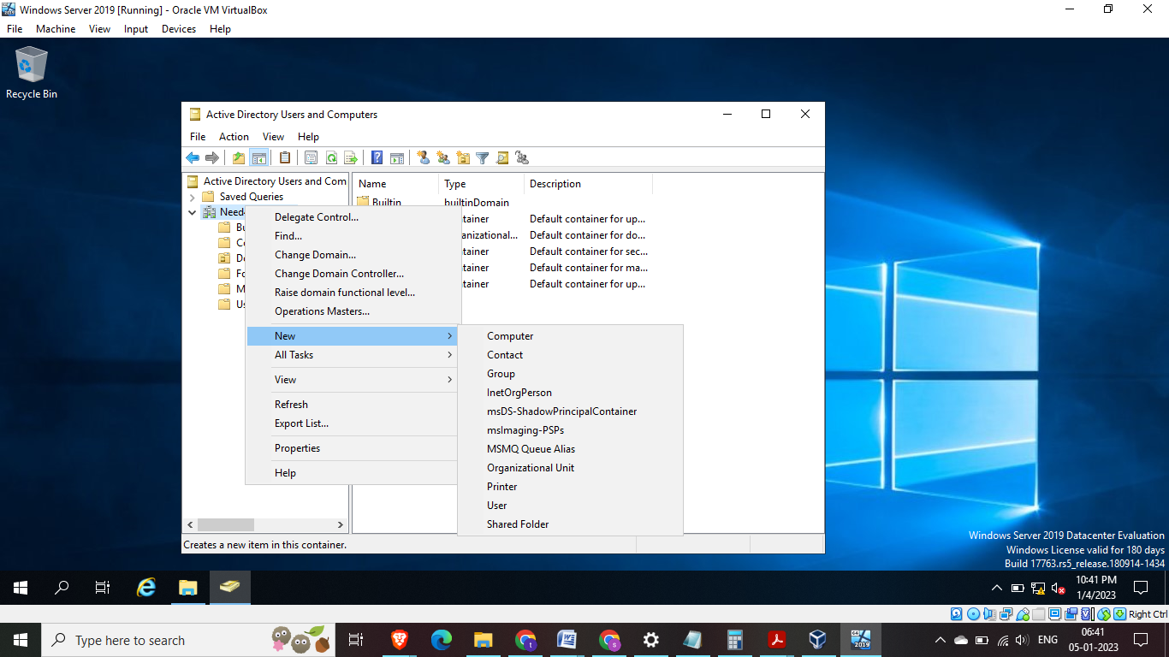

Fig 38: Create an Organizational unit > Enterprise

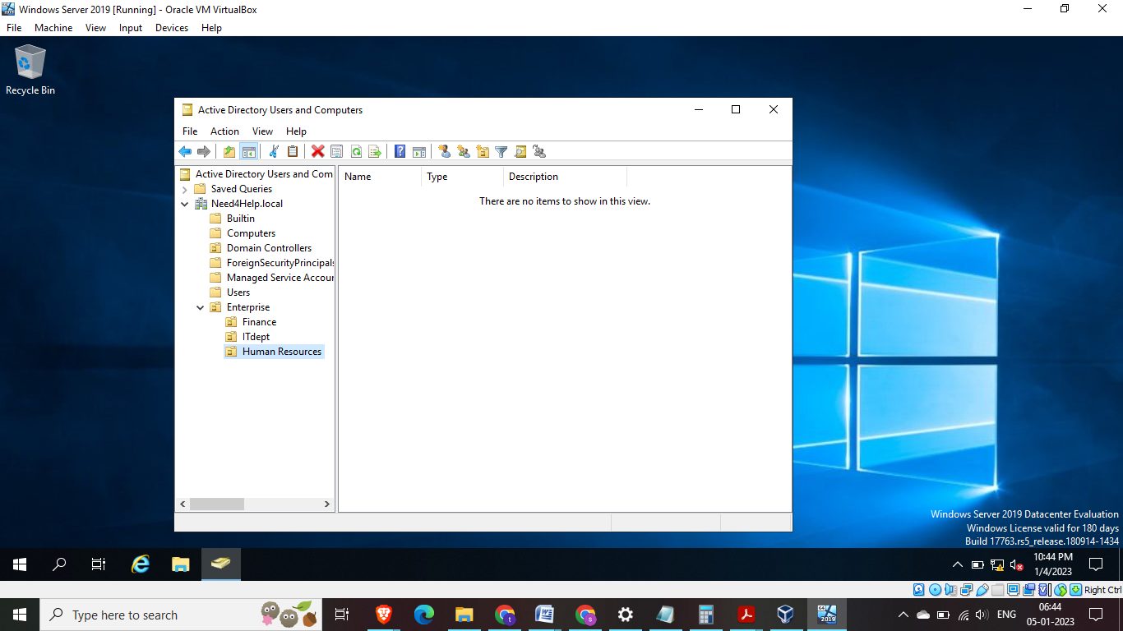

Fig 39: Under Enterprise we create further departments > Finance> IT > Human resources   
Steps to create is similar right click on Enterprise and click on Organizational unit

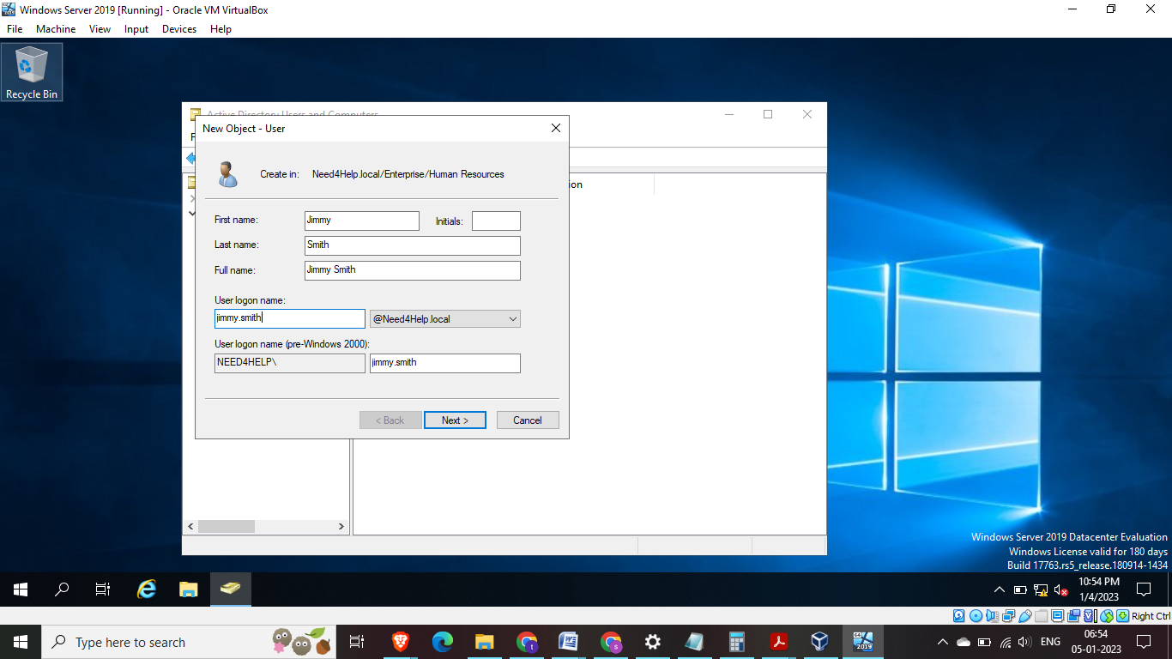

Fig 40: Create new user under Human resources

Fig 41: Assign new email id to the new user

## Create Security Group

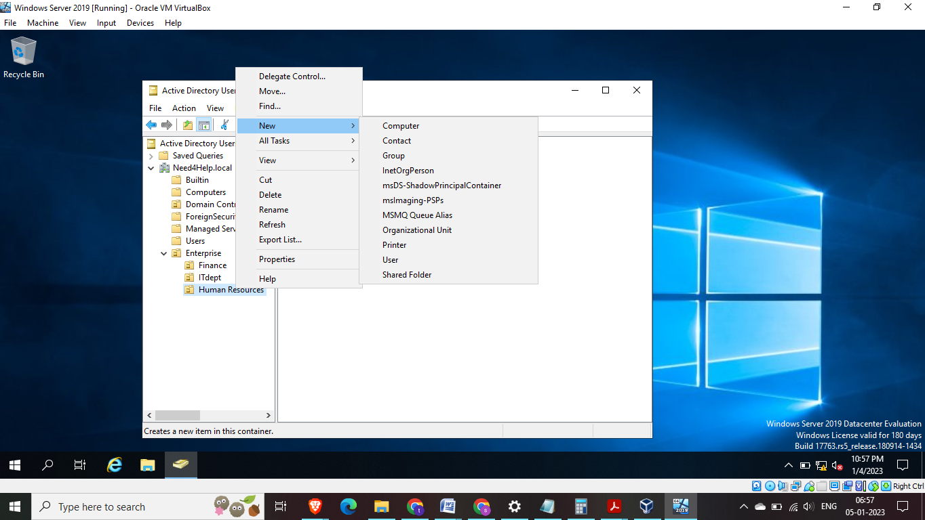Fig 42: To create security object right click on enterprise, click on Group

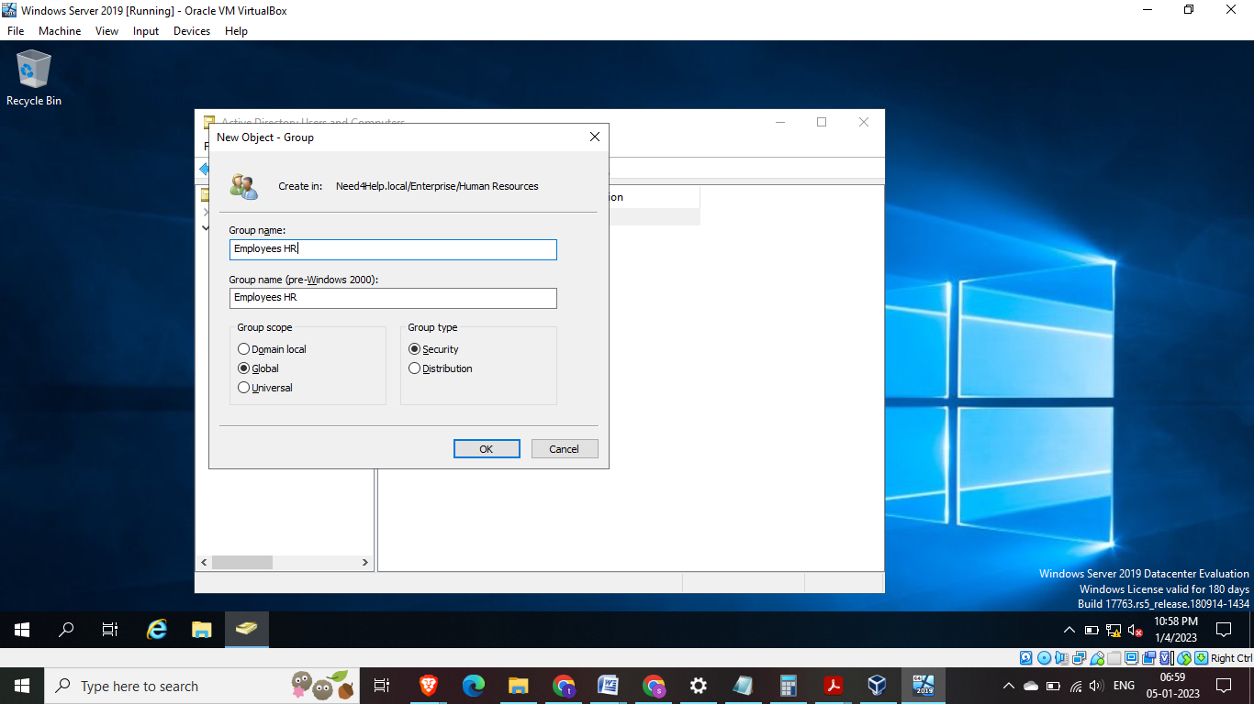

Fig 43: Create New group – Employees HR

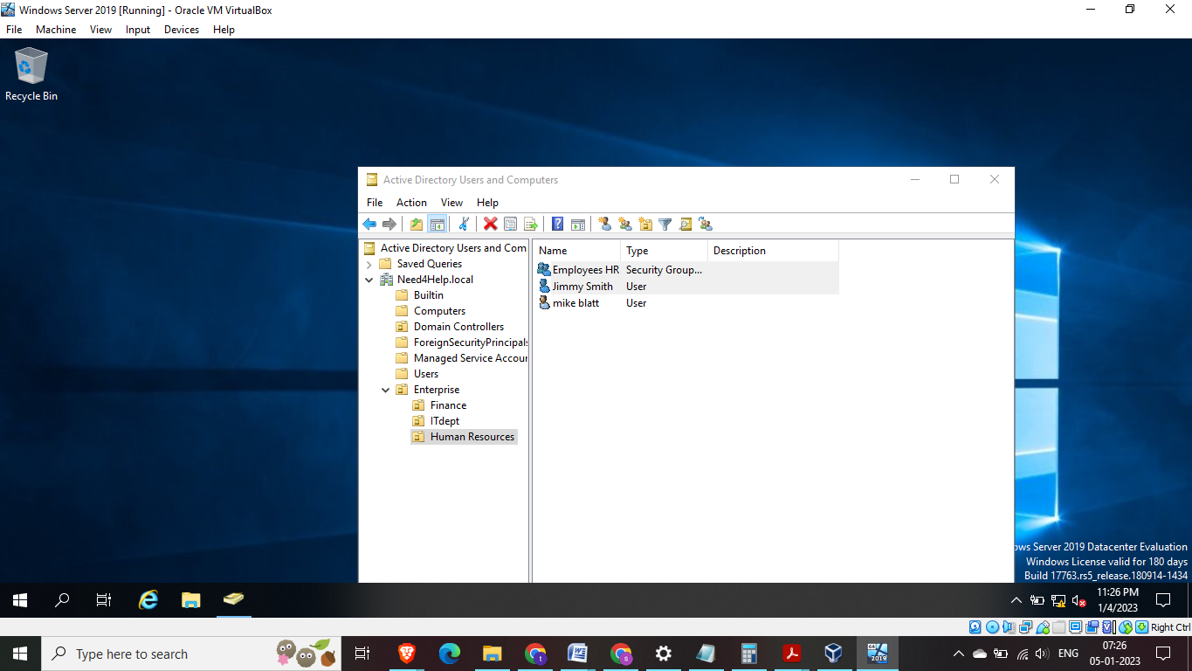

Fig 44: Organizational Security group is created. Note – its best practice to have separate security group for each department as they may have different admin rights

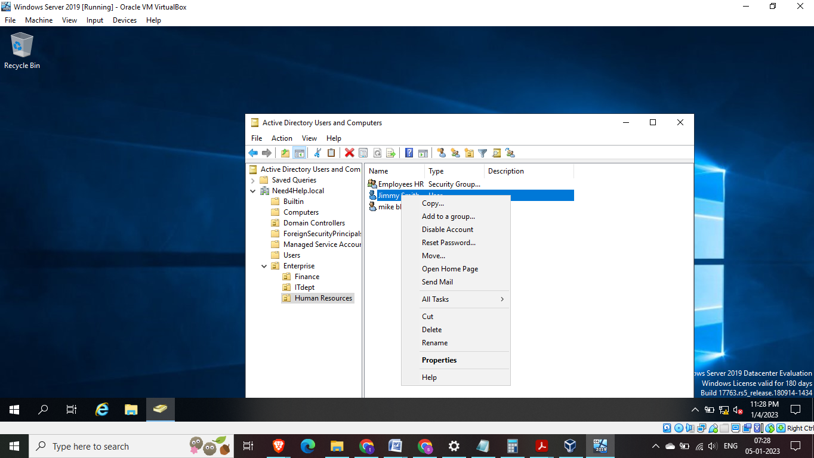

Fig 45: add the users of this dept to the security group that was created

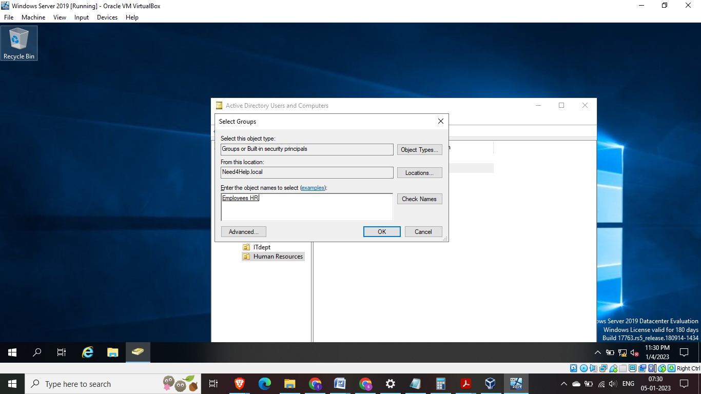

Fig 46: Employees HR group needs to be selected

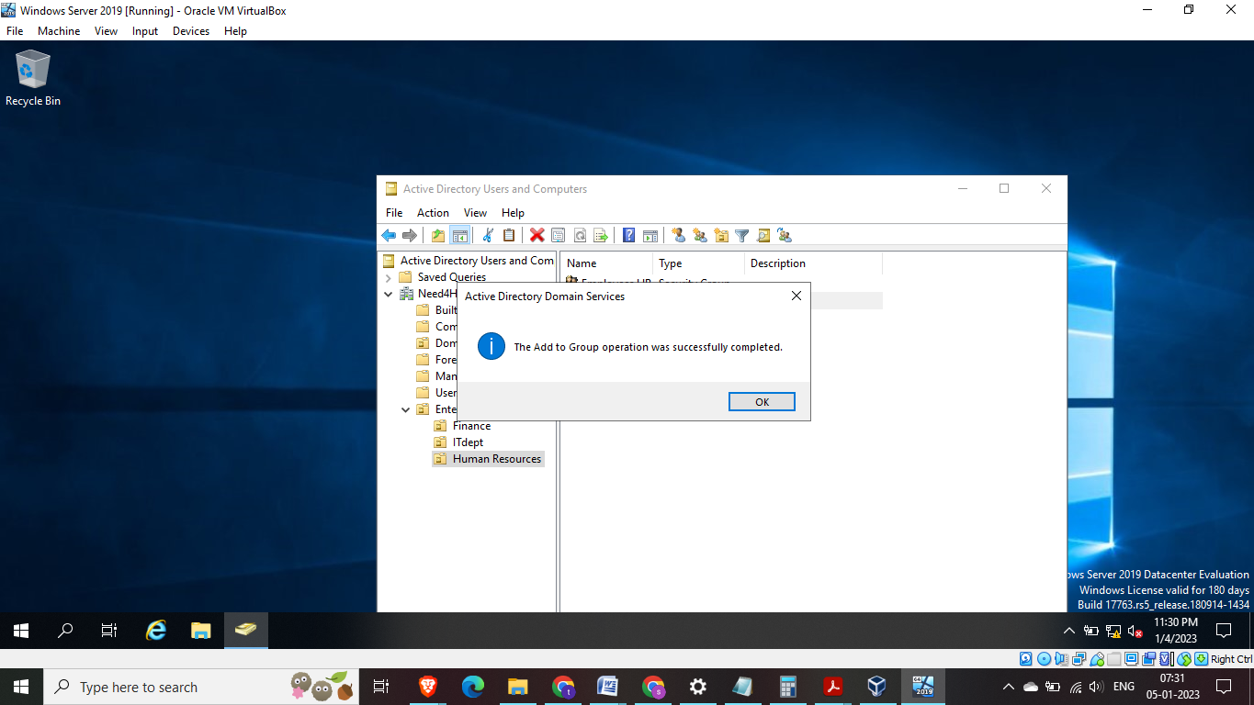

Fig 47: user was successfully added to the group

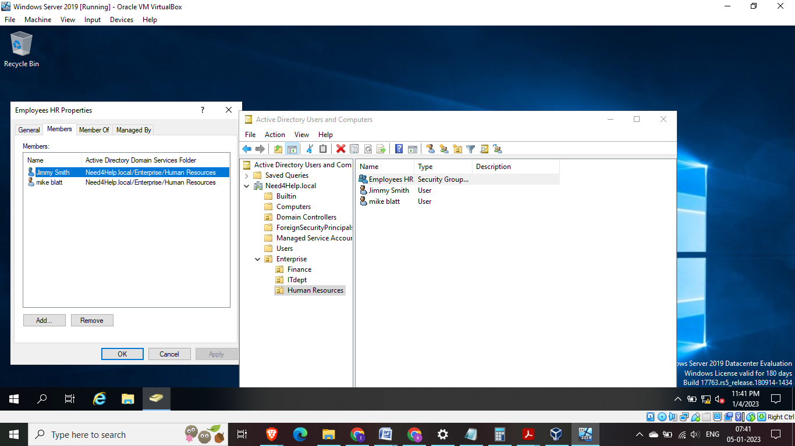

Fig 48: Now we can see the users part of security group

## Policy Management:

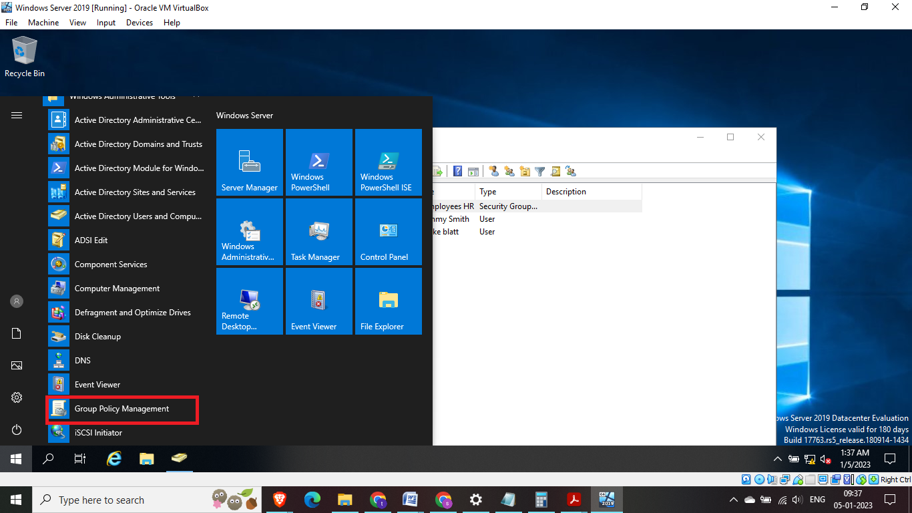Fig 49: To setup policy management – goto start > windows administrative tools > Group Policy Management

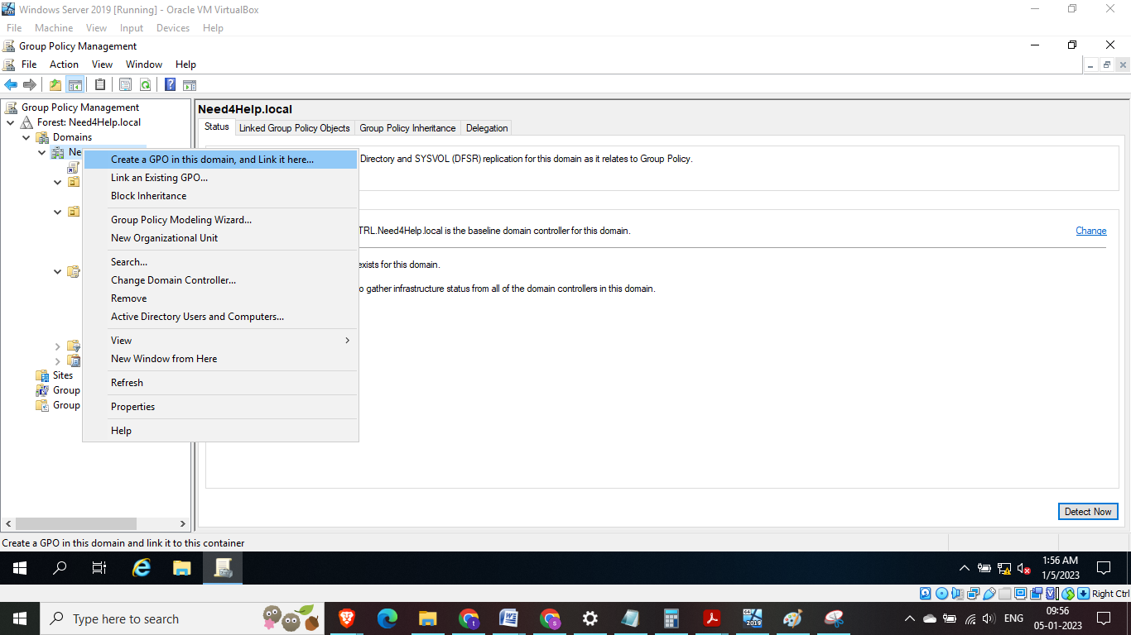Fig 50: Create a Group policy object in the main domain as Employees HR

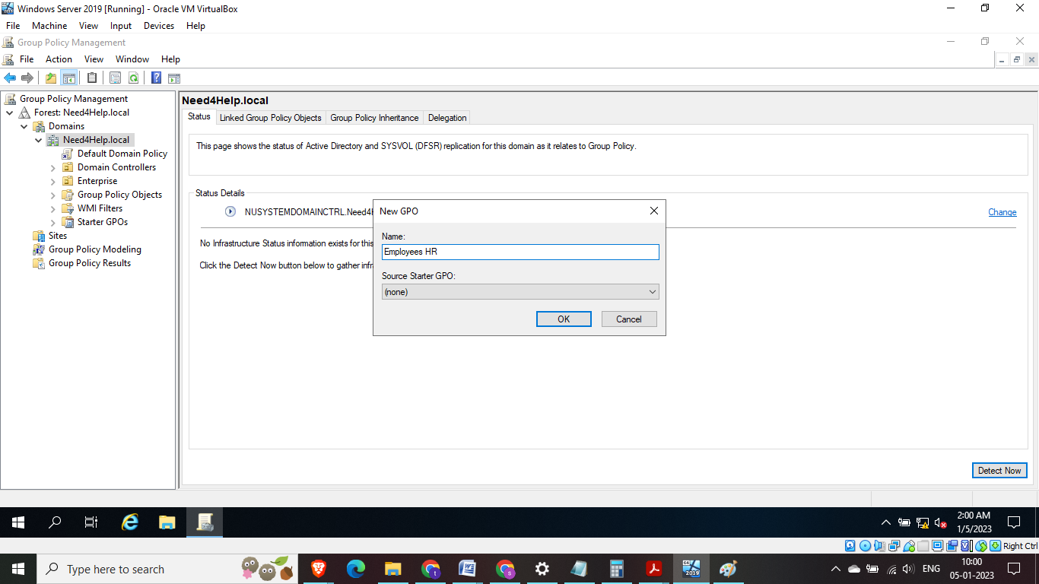

Fig 51: Create employees GPO – group policy object

## Adding Group users and Domain users:

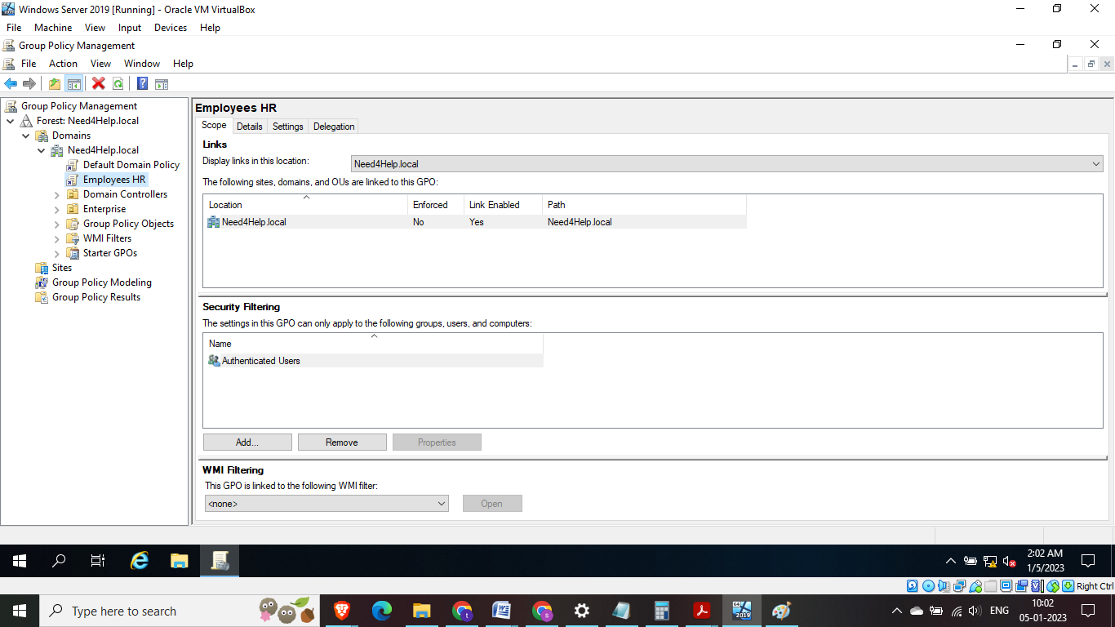Fig 52: Employees HR GPO is created

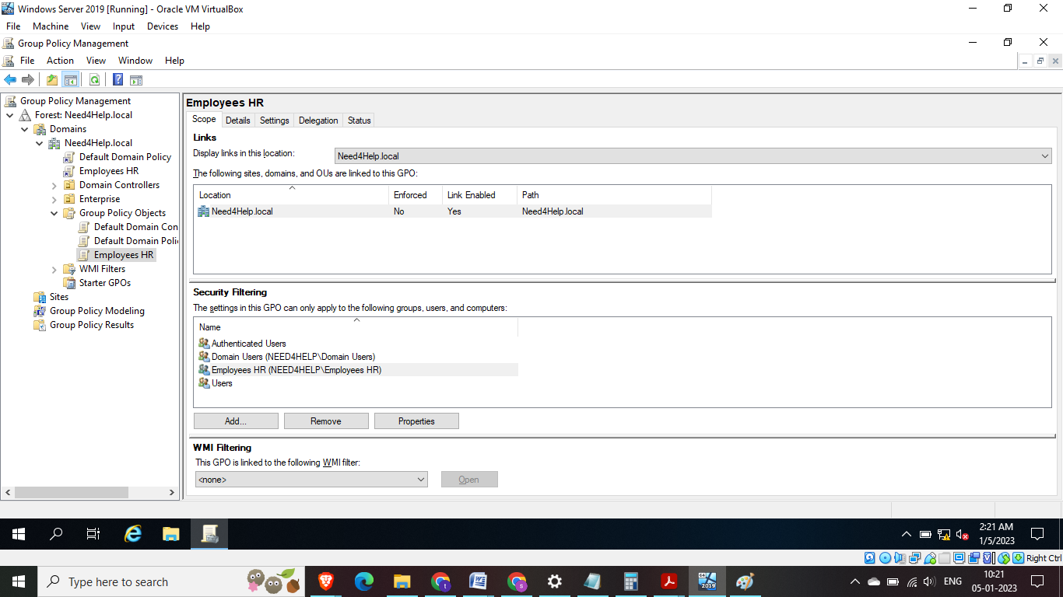

Fig 53: Add user and domain user and Employees HR as security filtering. The policy is going to be enforced for the groups under security filtering

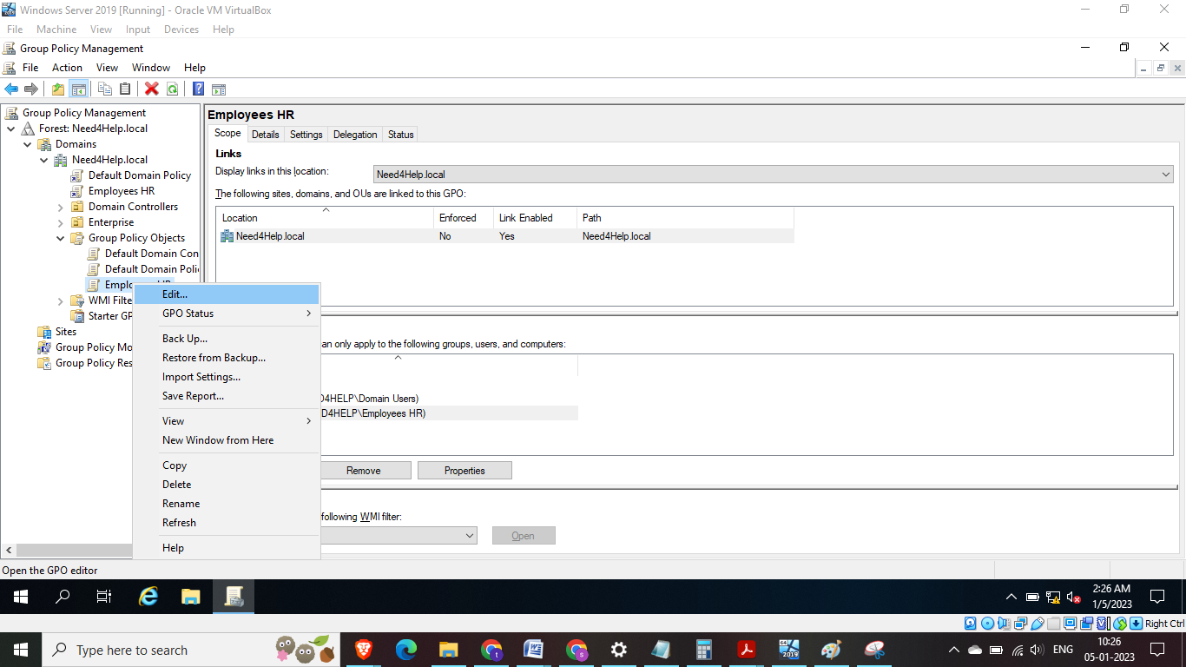

Fig 54: Click on edit Employees HR GPO

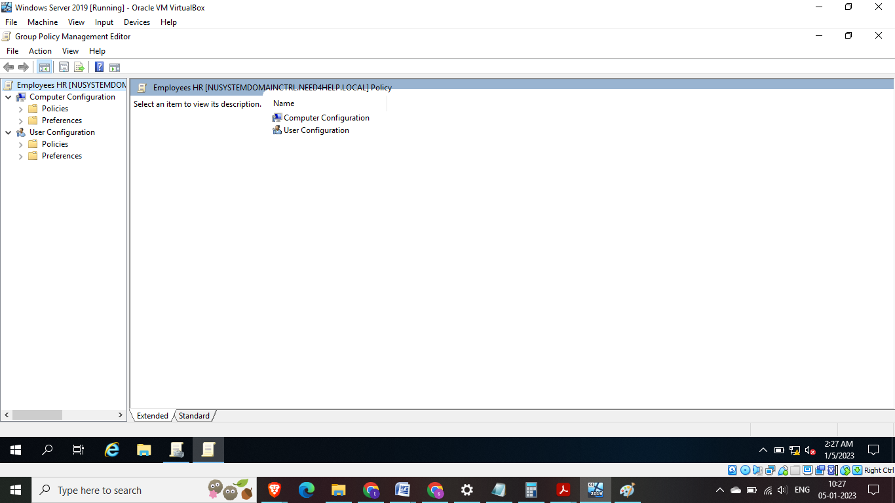

Fig 55: Group Policy Management Editor to setup configuration for Computer Configuration – which is related to computer and User Configuration – which is related to a specific user

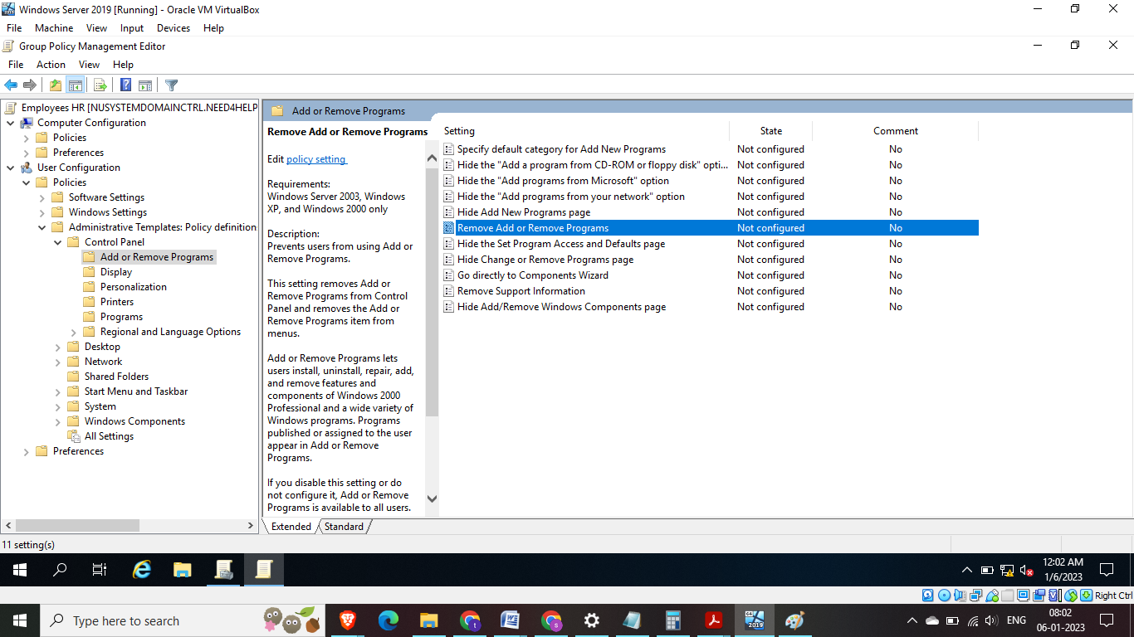  
Fig 56: Goto User configuration – Administrative Templates: Policy definition > Control Plan >Add or Remove Program > on the right panel Remove Add or Remove Programs – The intent is to setup a policy for user group to not allow them to use Add or Remove Programs Feature

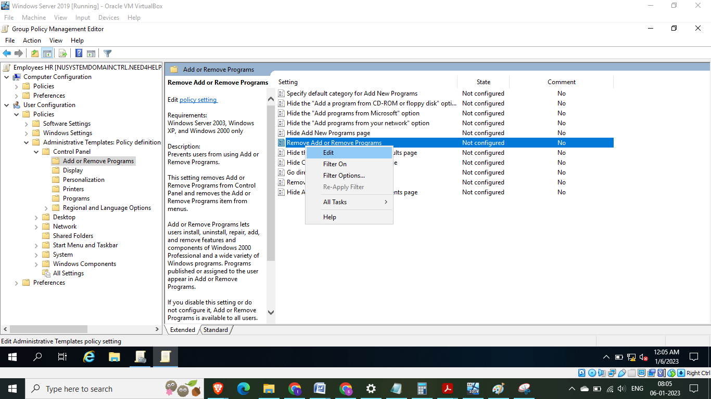

Fig 57: To edit default policy >Right click on Edit

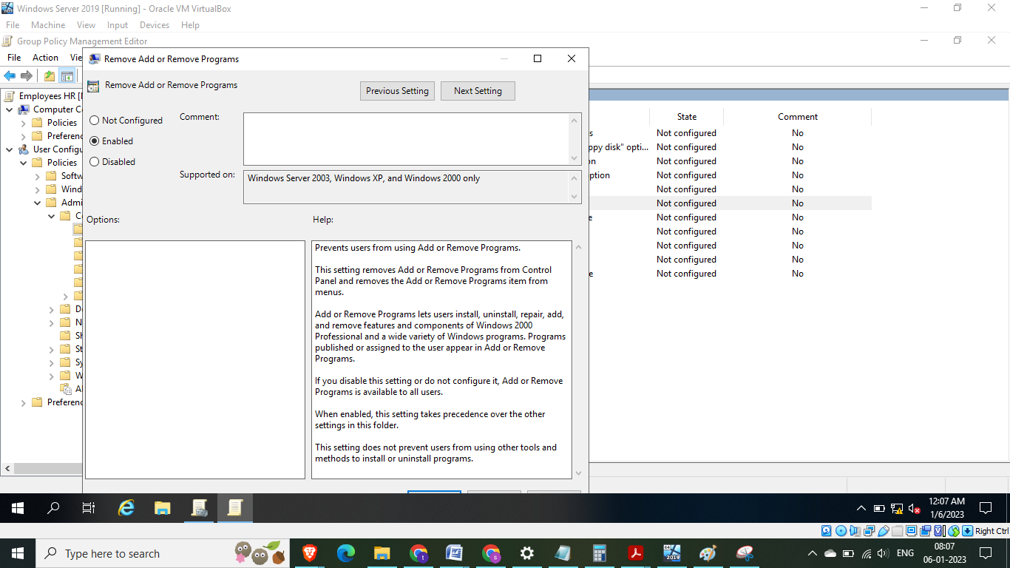

Fig 58: Select Enabled radio button and provide additional comments if needed

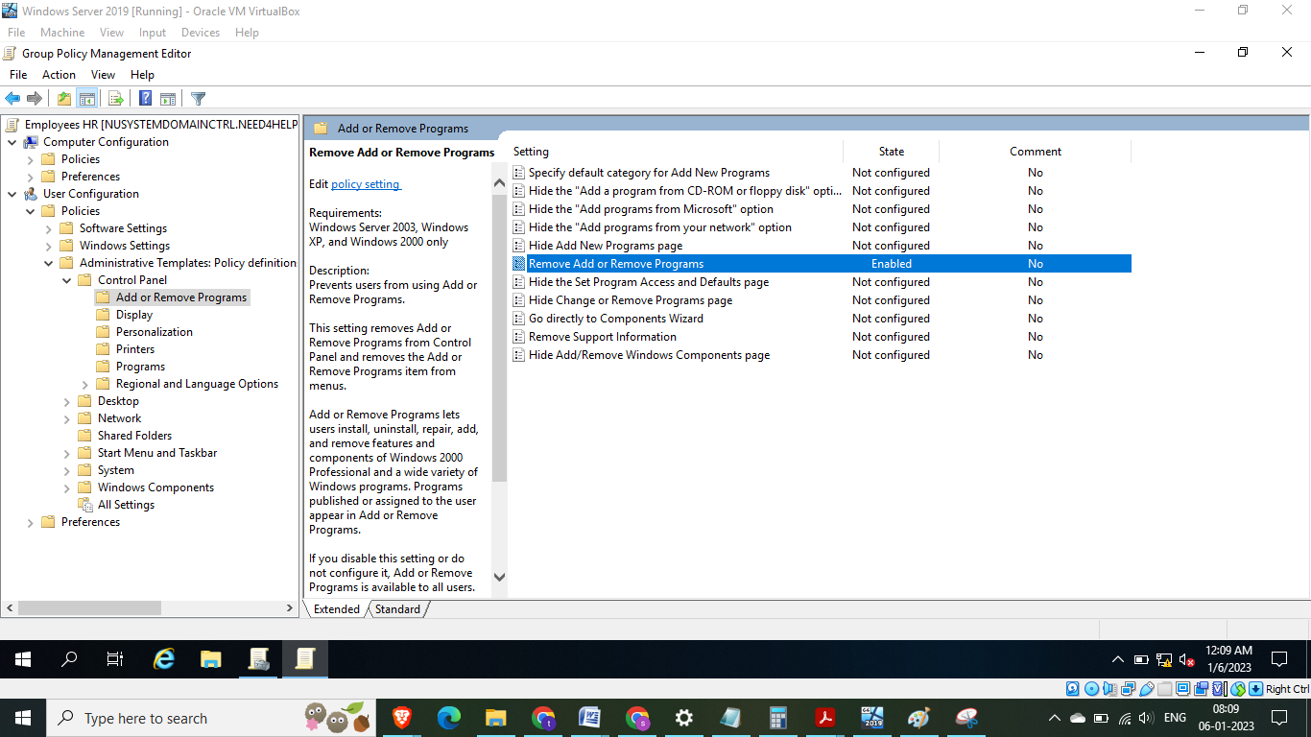

Fig 59: Now the state is ‘Enabed’

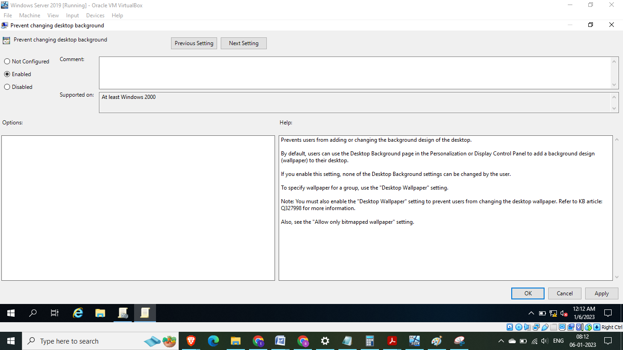

Fig 60: Similar to following above steps we will enable a policy to display desktop background

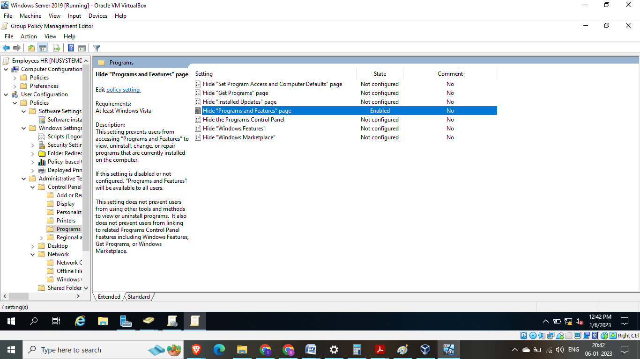

Fig 61: Similar to above step we enable a policy on Programs and Features – this will not allow the users to uninstall programs

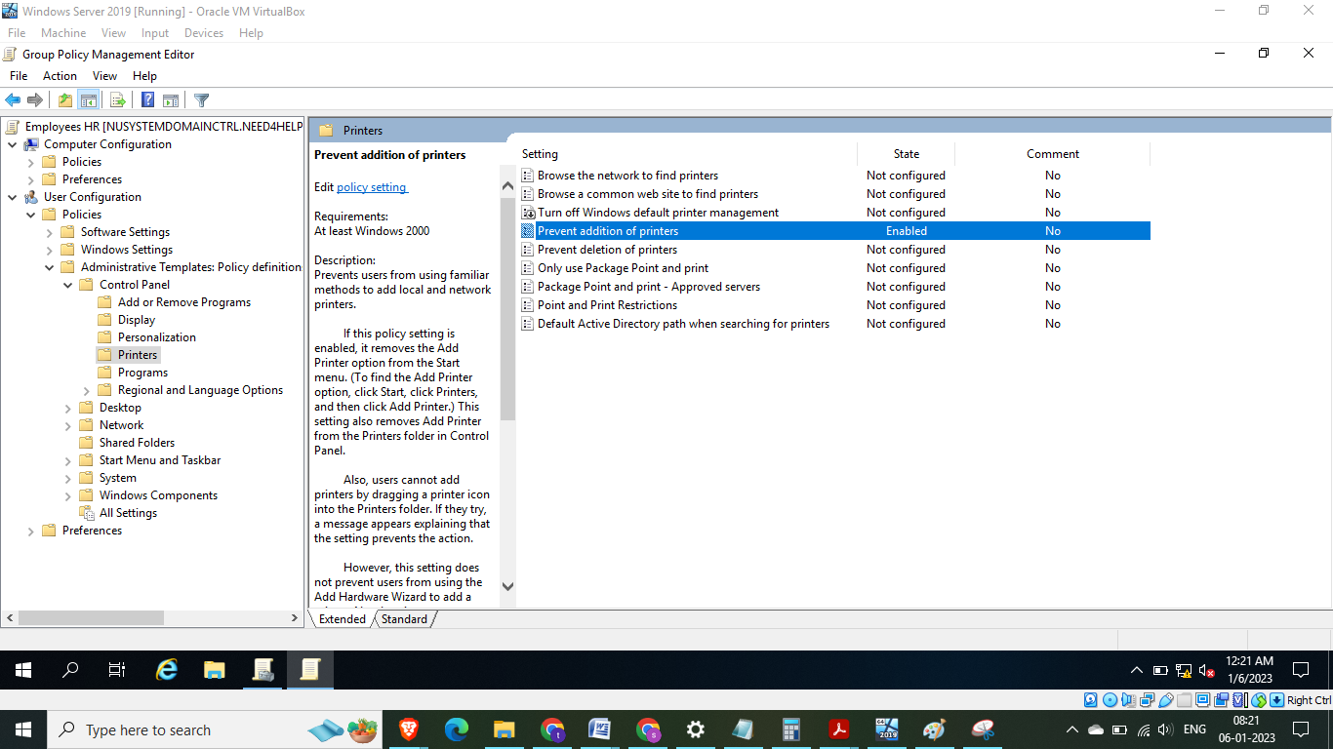

Fig 62: Similar to above steps we enable prevent additions of printers - only the printer that admin team has set up will work

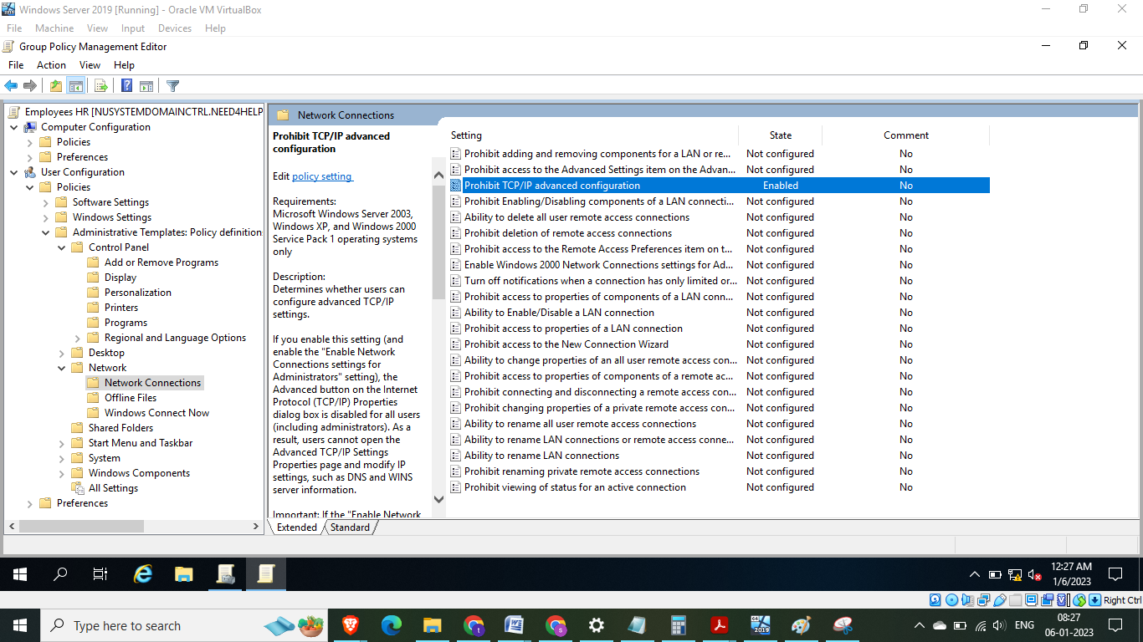Fig 63: Under Network connection similar to steps above we will enable policy on TCP/IP – this would block users from making any changes to the TCP/IP adress

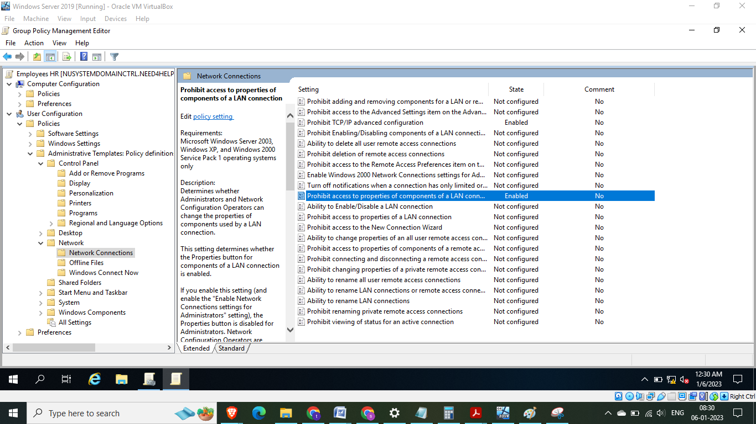Fig 64: similar to above steps we enable policy on Prohibits access to components of LAN connection

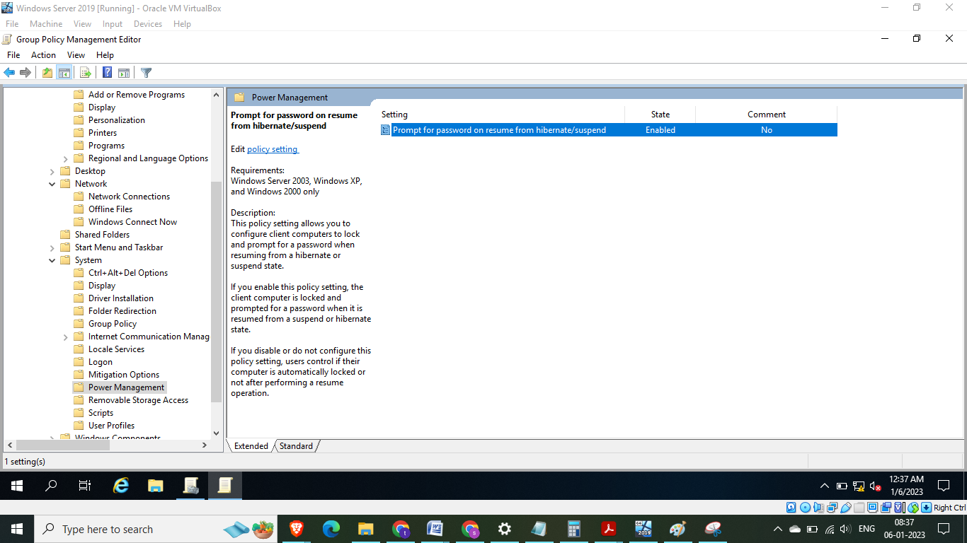

Fig 65: Similar to above step the Prompt for password on resume from Hibernate/suspended state is enabled – this is a very simple yet powerful policy that needs to be enabled

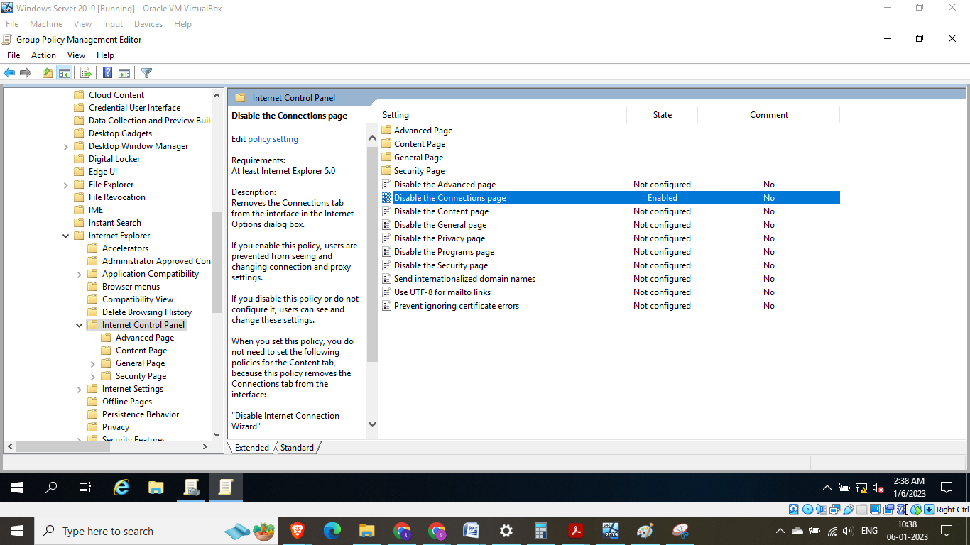

Fig 66: Similar to above step the disabling the connection page is important as this will prevent users from using internet with proxy IP address

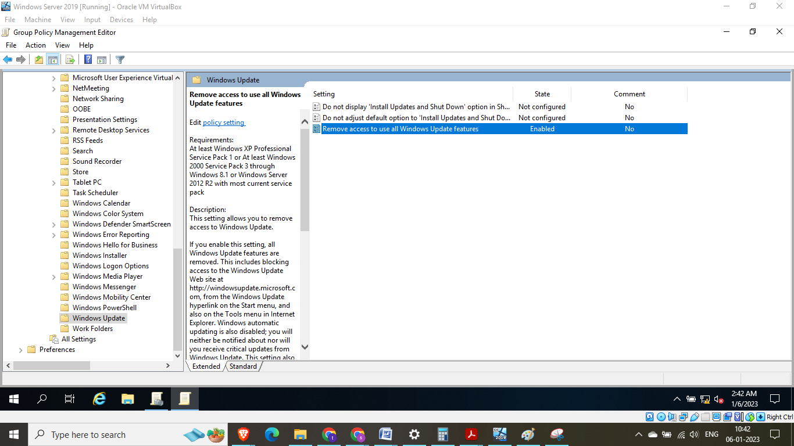

Fig 67: Similar to above step to enable policy on remove access to use all windows update function – this can only be done by IT admin

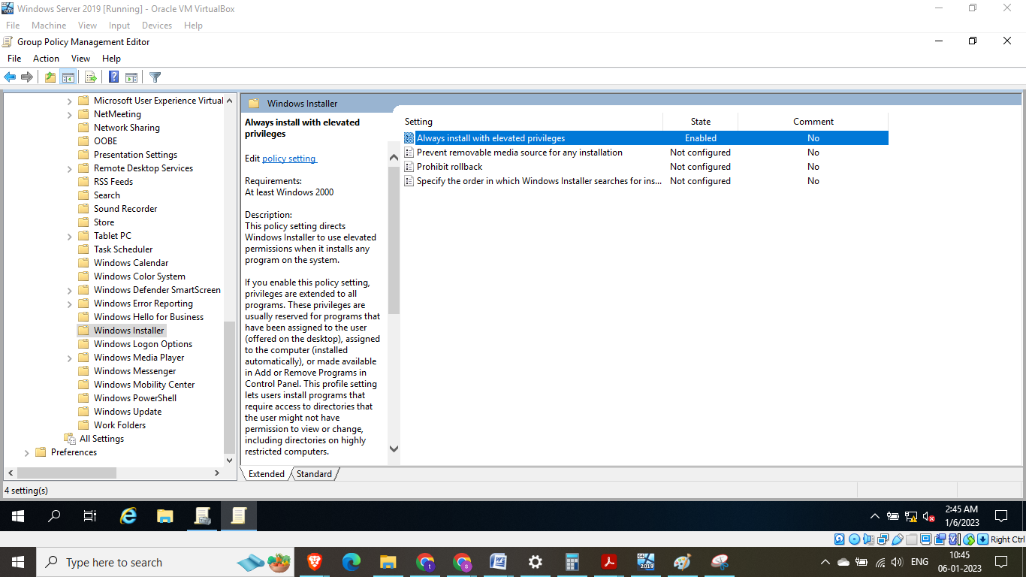

Fig 68: Similar to above step to enable policy to Always install with elevated privilages – this means that only IT admin can install programs and is disabled at user level

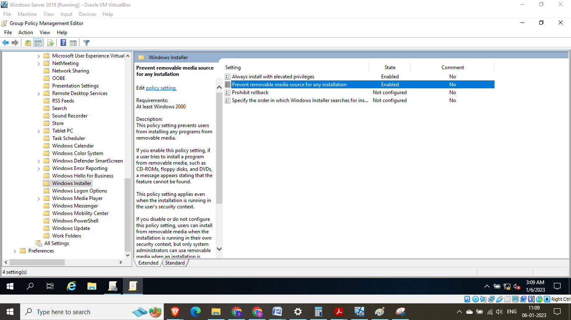

Fig 69: Similar to above step to enable policy to prevent from anyone installing program using external device like CD, USB

## Linking the group policy created to Organization unit

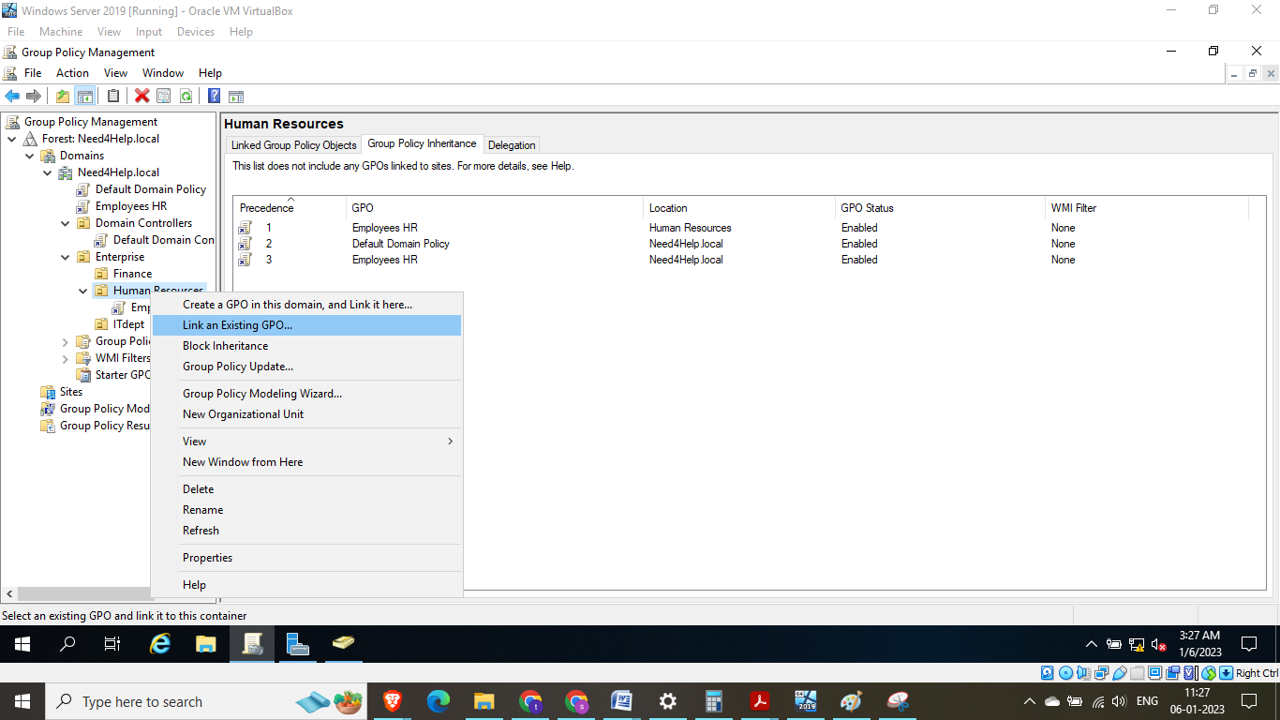

Fig 70: Linking the group policy created above to Organization unit

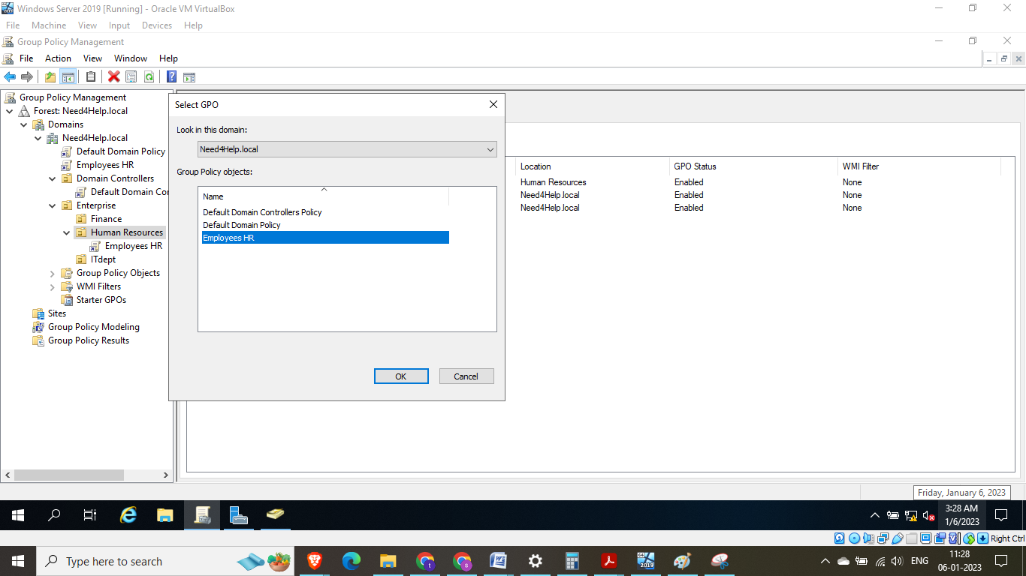

Fig 71: Select the Employees HR group policy that was created

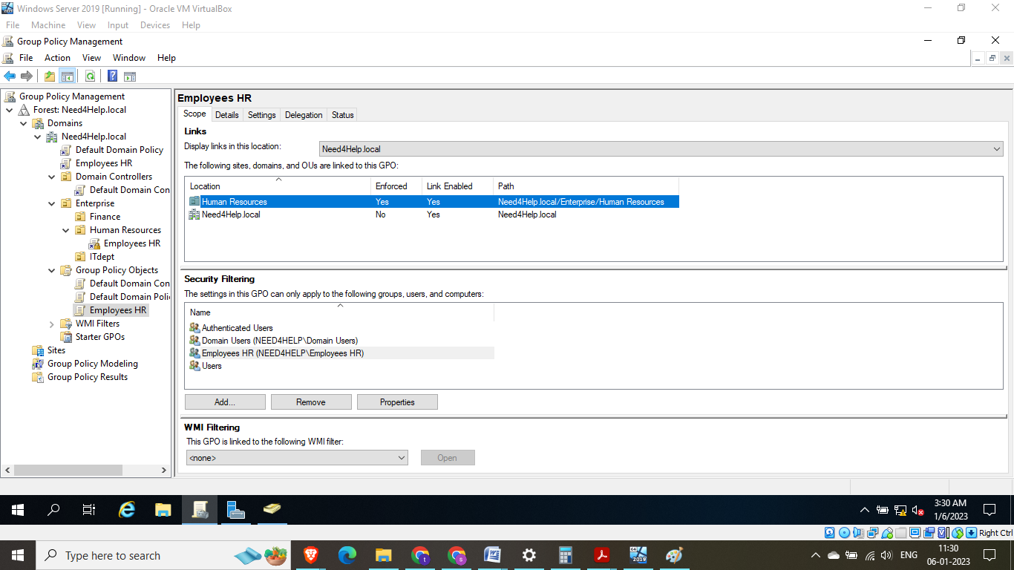

Fig 72: Now we can see the Group policy object is linked to the Organization unit (Employees HR)

## Validation of Group Policy Object Implementation:

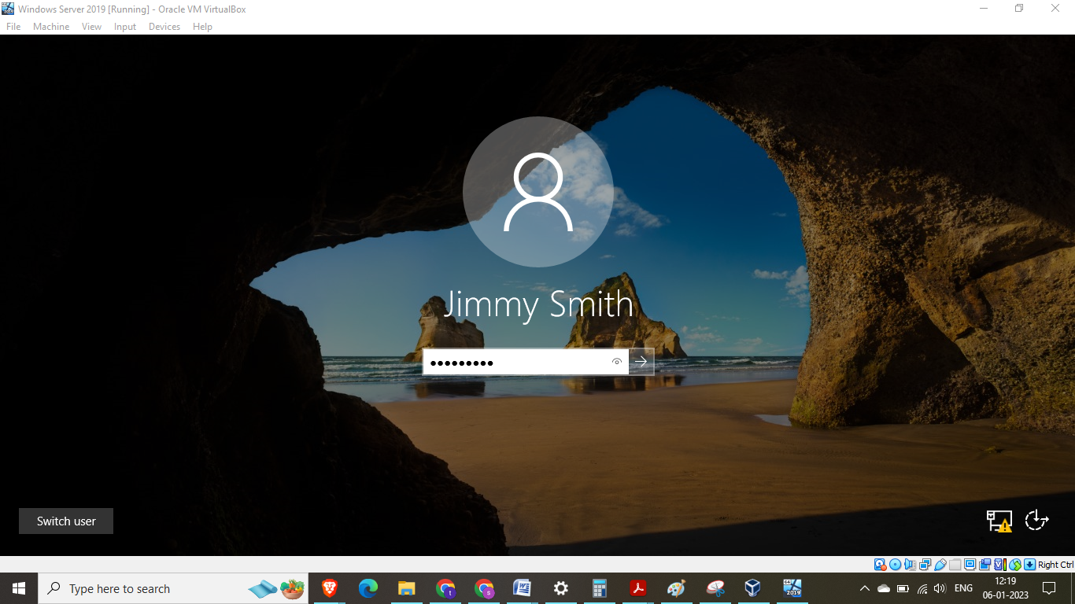Fig 73: Loging in as HR Employee user – Jimmy Smith

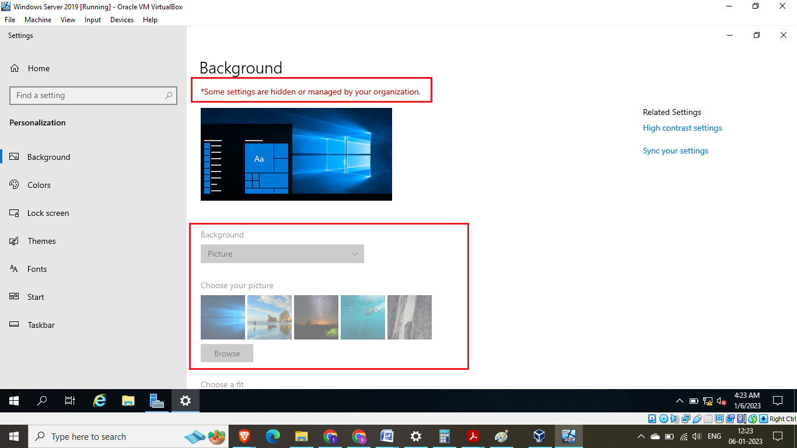

Fig 74: As we can see earlier policy regarding background disabling is in effect for this user – Jimmy smith . The background option has been greyed out and on the top there is a warning “Some setting are hidden or managed by your organization”

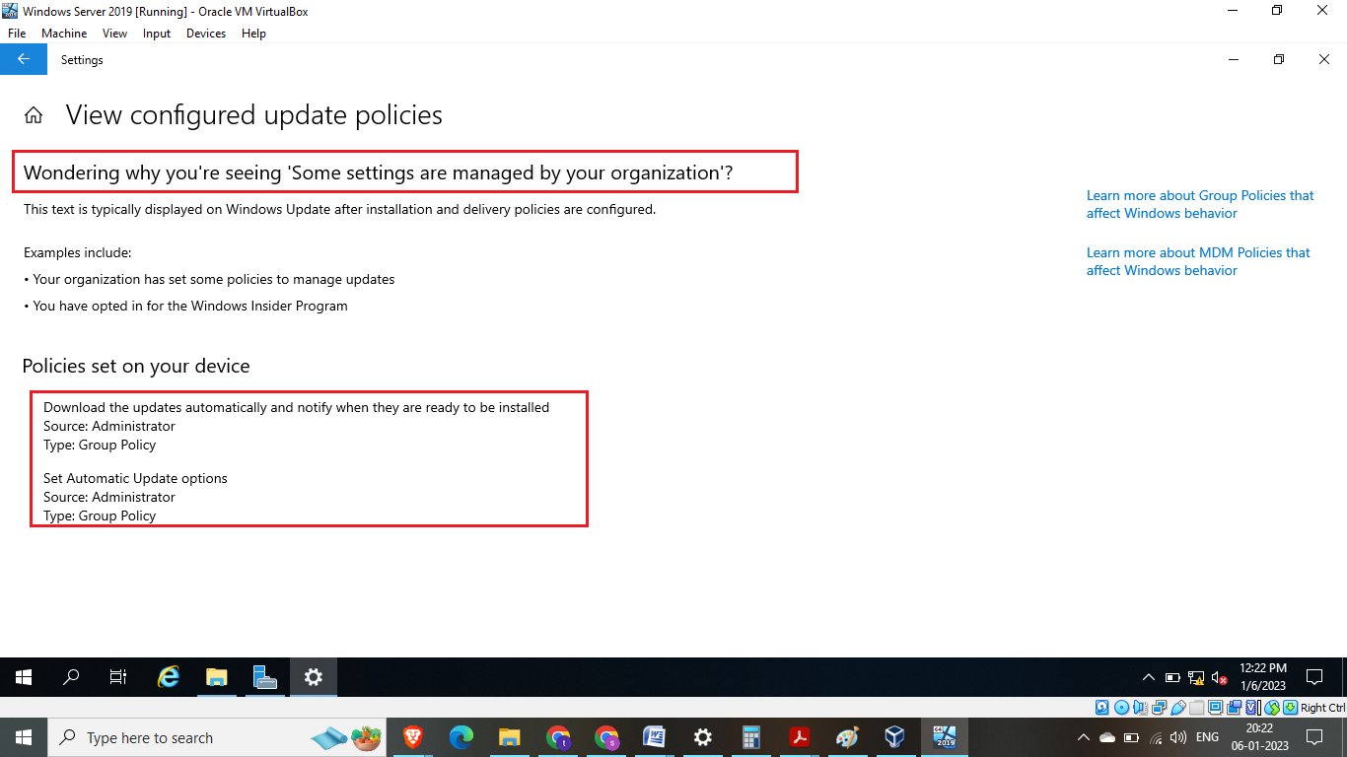

Fig 75: When we try to update windows we get this message for user Jimmy Smith – currently the administrator has set the windows update to automatic

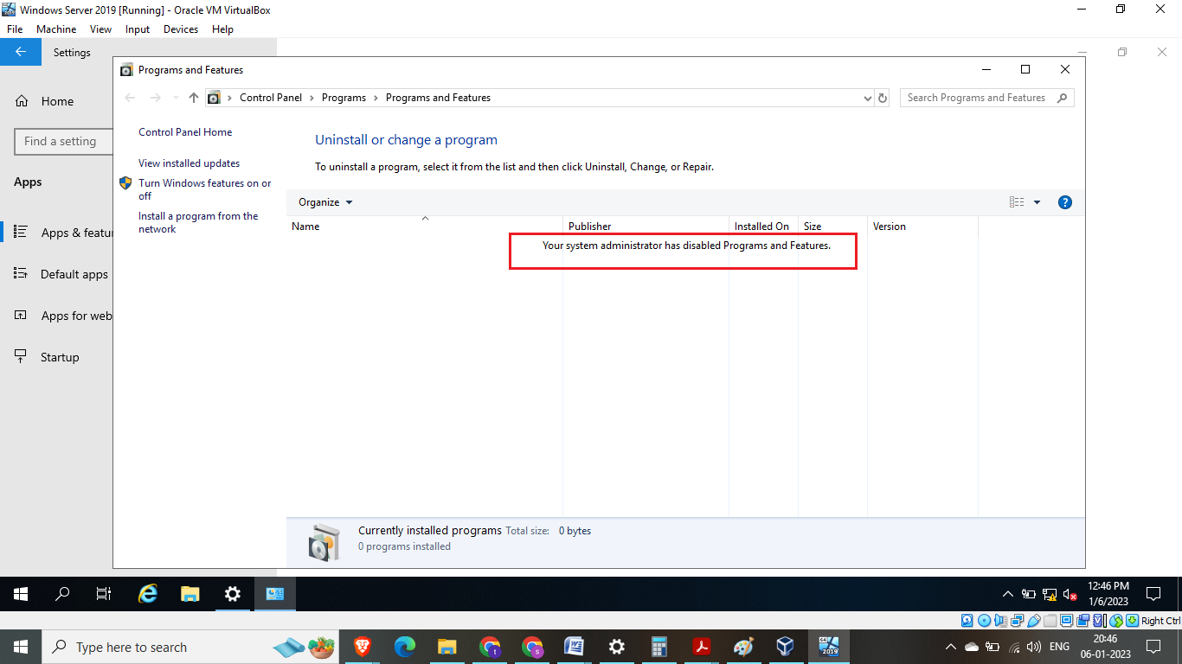

Fig 76: program adds or remove feature has been disabled for user Jimmy Smith.   
Similarly all security setting discussed above in Group Policy Object using Active directory feature improves security for an organization on its computer security.

Task 5: Social, Ethical and Legal Considerations

The code of conduct required for an IT professional have a duty to uphold a code of behaviour that considers social, ethical, and legal issues in the field of computer security. (International Association of Computer Science and Information Technology, n.d.). This code of conduct establishes expectations for appropriate conduct and aims to guarantee that IT professionals act morally, responsibly, and in accordance with all applicable rules and laws.

A code of ethics for the field of computer science and information technology might contain the following common principles:

Responsibility: Professionals ought to accept accountability for their deeds and the results of their labour.

Confidentiality: Professionals should respect information confidentiality and safeguard others' privacy.

Integrity: Professionals should conduct themselves in an ethical and transparent manner and refrain from any behaviors that can jeopardize their integrity.

Fairness: When dealing with others, professionals should be neutral and fair.

Respect**:** Professionals ought to respect other people's rights and dignity and refrain from treating others unfairly because of their color, gender, religion, or sexual orientation. (ACM Council, 2018)

Some key elements of this code of conduct may include:

1.Professionalism:IT employees should always act professionally, especially when speaking with coworkers, clients, and customers (International Association of Computer Science and Information Technology, n.d.). This can entail acting in a polite and professional manner, keeping information private, and following accepted norms and guidelines (International Association of Computer Science and Information Technology, n.d.).

2.Ethical behavior: IT professionals should act ethically and with integrity, including avoiding actions that may harm others or compromise the security of systems and data (International Association of Computer Science and Information Technology, n.d.). This may include following laws and regulations, respecting the privacy of others, and avoiding activities that could be perceived as unethical or dishonest. (ACM Council, 2018)

3.Social responsibility: IT professionals ought to be conscious of how their job affects society and seek to apply their knowledge and abilities for the good of society (International Association of Computer Science and Information Technology, n.d.). This might entail supporting diversity and inclusion, reflecting on the ethical ramifications of their work, and being aware of how their actions may affect others (International Association of Computer Science and Information Technology, n.d.).

4.Legal compliance**:** IT professionals working in the field of computer security should be aware of and abide by the laws and regulations governing data privacy, cybersecurity, and intellectual property (International Association of Computer Science and Information Technology, n.d.). This can mean abiding by standards and laws specific to the industry, acquiring necessary approvals and licenses, and implementing safety measures to guard against cyberthreats (International Association of Computer Science and Information Technology, n.d.).

In **Conclusion**, IT professionals have a duty to uphold a code of behaviour that considers social, ethical, and legal issues in the field of computer security. Following this code of conduct will help IT professionals maintain the respect of their co-workers, clients, and customers by acting in a professional, moral, and responsible manner. (ACM Council, 2018)

Conclusion: In conclusion, it is clear that Need4Help, a charity with UK roots that uses shared computers to store personal information about donors and those in need, places a high priority on computer security. To guard against cybersecurity breaches and attacks like malware and phishing, Need4Help must take steps to mitigate these risks and ensure the Confidentiality, Integrity, and Availability of the data it holds.

It is advised that Need4Help set in place a strong framework for computer security that incorporates the most recent defences against cyberthreats to deal with these concerns. In order to avoid malware infections and phishing assaults, this could involve the usage of email filtering and antivirus software, as well as routine software updates and employee training on how to spot and report unusual activity.

To improve its computer security, Need4Help should also think about adding user access control mechanisms. This could entail assigning various levels of access to various employees, requiring secure passwords, and periodically reviewing and revoking access as necessary. These actions will help Need4Help better safeguard its valuable information while lowering the likelihood of a cybersecurity breach.

# References

1. Schaumann, 2022. *Twitter.* [Online] Available at: https://twitter.com/jschauma/status/1220904655753969664  
   [Accessed 04 Jan 2023].
2. ACM Council, 2018. *ACM Code of Ethics and Professional Conduct.* [Online]   
   Available at: https://www.acm.org/code-of-ethics  
   [Accessed )5 Jan 2023].
3. Bulao, 2022. *DREAD Threat Modeling: An Introduction to Qualitative Risk Analysis.* [Online]   
   Available at: https://www.eccouncil.org/cybersecurity-exchange/threat-intelligence/dread-threat-modeling-intro/[Accessed 05 Jan 2023].
4. chowdhury, 2019. *INTRODUCTION TO CYBER THREAT INTELLIGENCE (CTI): A DEFINITIVE GUIDE FOR THE BEGINNERS.* [Online]   
   Available at: https://hackersterminal.com/cyber-threat-intelligence-cti/  
   [Accessed 04 jan 2023].
5. EC-Council, 2022. *Cyber Threat Modelling.* [Online]   
   Available at: https://www.eccouncil.org/threat-modeling/  
   [Accessed 04 Jan 2023].
6. Gaithersburg,MD, 2013. *Satisfy NIST Cybersecurity Framework, DFARS, 800-171,* Silicon valley: Beachhead Solution.
7. Guru, 2021. *What is COBIT Framework – Components, Structure & Advantages.* [Online]   
   Available at: https://cybersecuritynews.com/what-is-cobit-framework/  
   [Accessed 05 Jan 2023].
8. Kaspersky, 2023. *What is threat intelligence? Definition and explanation.* [Online]   
   Available at: https://www.kaspersky.com/resource-center/definitions/threat-intelligence  
   [Accessed 04 Jan 2023].
9. Kost, 2022. *What is Threat Modelling? 10 Threat Identity Methods Explained.* [Online]   
   Available at: https://www.upguard.com/blog/what-is-threat-modelling  
   [Accessed 04 Jan 2023].
10. NIST, 2021. *Uses and Benefits of the Framework.* [Online]   
    Available at: https://www.nist.gov/cyberframework/online-learning/uses-and-benefits-framework  
    [Accessed 05 Jan 2023].
11. Reciprocity, 2022. *Top Threat Modeling Methodologies.* [Online]   
    Available at: https://reciprocity.com/blog/top-threat-modeling-methodologies/  
    [Accessed 04 Jan 2023].
12. River, 2022. *What Is Threat Modelling.* [Online]   
    Available at: https://www.windriver.com/solutions/learning/threat-modeling  
    [Accessed 04 jan 2023].
13. Sec, 2022. *ISO-27001, ISA/IEC-62443, and NIST CSF: Selecting the right standard/framework for your OT cybersecurity program.* [Online]   
    Available at: https://www.intechww.com/iso-27001-isa-iec-62443-and-nist-csf-selecting-the-right-standard-framework-for-your-ot-cybersecurity-program/  
    [Accessed 05 Jan 2023].
14. Seymour,Bosworth & Kebay, 2002. *Computer Security Handbook.* 4th ed. New York: s.n.
15. Stanislav & Williams, 2014. Information Security. In: *Principles and Practices.* s.l.:syngress.
16. Cyber Security Breaches Survey 2019: <https://www.gov.uk/government/statistics/cyber-security-breaches-survey-2019>
17. Crime Survey for England and Wales(CSEW)https://www.ons.gov.uk/peoplepopulationandcommunity/crimeandjustice/bulletins/crimesurveyenglandandwales/yearendingmarch2020
18. NIST Cybersecurity Framework: Available at: https://www.nist.gov/cybersecurity-framework Table 2: Security frameworks comparison (Source: Author)
19. Risk management approach to cybersecurity: SANS Institute, "Implementing a Risk Management Framework: A Practical Guide", <https://www.sans.org/reading-room/whitepapers/frameworks/implementing-risk-management-framework-practical-guide-33758>
20. Maryville Online. 2022. Common Cybersecurity Issues That Organizations Face | Maryville Online. [ONLINE] Available at: <https://online.maryville.edu/blog/cybersecurity-issues> [Accessed 04 Jan 2023].
21. Microsoft TechNet. (n.d.). Active Directory. [ONLINE] Available at: <https://docs.microsoft.com/en-us/windows-server/identity/active-directory/active-directory-what-is-active-directory> [Accessed 04 Jan 2023]
22. Microsoft TechNet. (n.d.). Group Policy. [ONLINE] Available at: [https://docs.microsoft.com/en-[Accessed 04 Jan 2023]us/windows/security/threat-protection/windows-defender-security-center/manage-group-policy](https://docs.microsoft.com/en-us/windows/security/threat-protection/windows-defender-security-center/manage-group-policy)
23. International Association of Computer Science and Information Technology. (n.d.). Code of ethics. [ONLINE] Available at: <https://www.iacsit.org/code-of-ethics/>[Accessed 04 Jan 2023]